**Number and Place Value**

**Year 1**

**Count forwards and backwards within 100.**

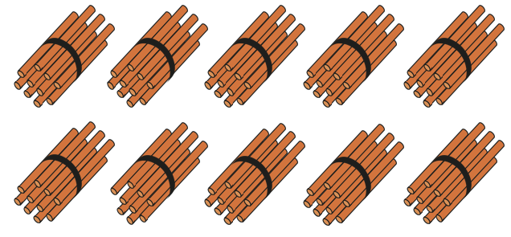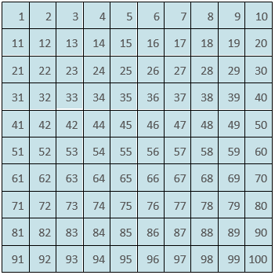

**Count with straw bundles grouped into 10s.**

*Eight, nine, ten, eleven, twelve….thirty eight, thirty nine, forty, forty one…*

*Eight, nine, ten, one-ten-one, one-ten-two, one-ten-three…*

*Three-tens-eight, three-tens- nine, four tens, four-tens-one…*

**Count on a hundred square**



**Count using a number line.**

**1 2 3 4 5 6 7 8 9 10 11 12…**

**Count using digits.**

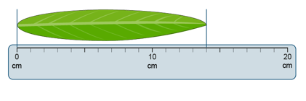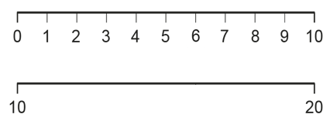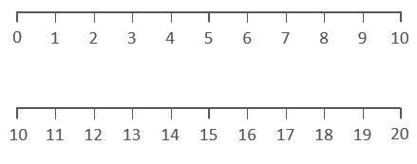

**Number and Place Value**

**Year 1**

**Numbers to 20 in the linear number system.**

**Make connections to use of measures eg. Ruler to 20**

**Extend to estimating where numbers sit on the blank number line.**

**Estimate where numbers sit on the number line.**

**Make connections between 0-10 and 10-20 number lines.**

**Recognise the position of each number on the number line.**

**Vocabulary:**

Ones Tens Digit Represents Place Value Chart Column Model Part Whole Addend Sum Minuend Subtrahend Difference Plus Minus Equals Combine Partition

**Number and Place Value**

**Year 2**

**Place Value in 2-digit numbers (1)**

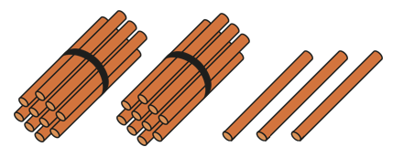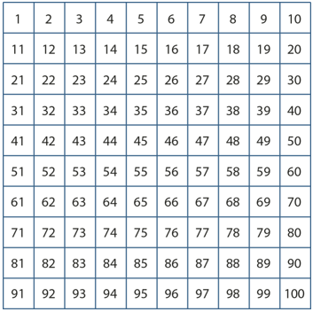





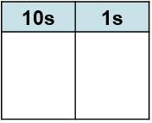

**Recognise 2-digit numbers are composed of tens and ones.**

**Locate the position of two-digit numbers on a 100 square and make connections with other 2-digit numbers.**

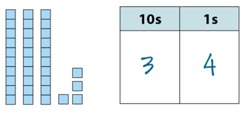

**Create 2-digit numbers using Deines and record the number numerically.**

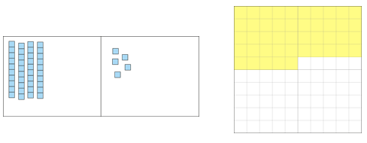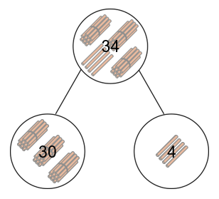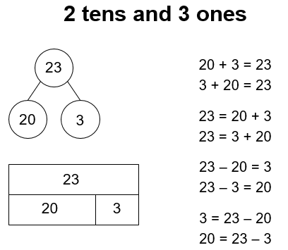

**Vocabulary:**

Ones Tens Digit Represents Place Value Chart Column Model Part Whole Addend Sum Minuend Subtrahend Difference Plus Minus Equals Combine Partition

**Number and Place Value**

**Year 2**

**Place Value in 2-digit numbers (2)**

**Make connections between the Deines and 100 square.**

**Partition 2-digit numbers into tens and ones.**

**Partition 2-digit numbers in the abstract forms of bar model and part-part-whole model (cherry model)**

**Record our understanding as additive equations.**

**Vocabulary:**

Ones Tens Place Value Number Line Multiple Previous Next

Bead string/bar

**Number and Place Value**

**Year 2**

**Two-digit numbers in the linear number system.**

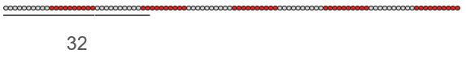

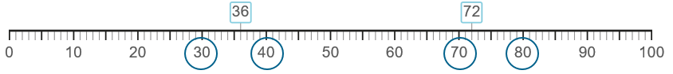

**Identify the number that sits halfway between 0 and 100. Make connections to 0-10 number line.**

**Estimate the position of 2-digit numbers on the blank number line.**

**Identify the previous and next multiple of ten that a number sits between.**

**36 is between 30 and 40.**

**30 is the previous multiple of 10. 40 is the next multiple of 10.**

**Make connections between the bead string and the number line.**

**Describe the number of beads in tens and ones.**

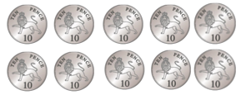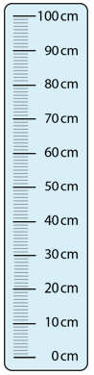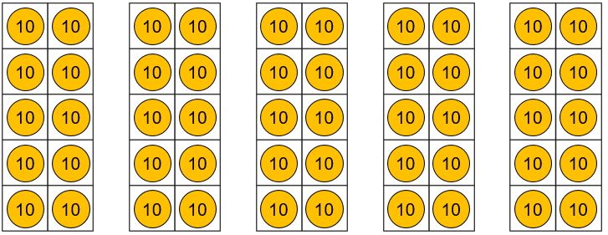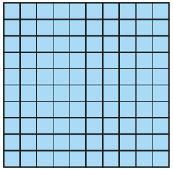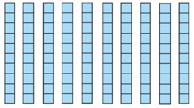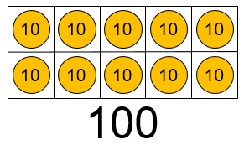

**Vocabulary:**

Ones Tens Hundreds Place Value Digit Represents Counters Pence Coin Tens Frame Multiple Previous Next Deines One-tenth the size Ten-times the size Centimetres Metres

*Metres*

**Recognise the number of tens in a three-digit number.**

***10 tens are equivalent to 100.***

***18 tens are equivalent to 180.***

**Make connections to other forms of measure eg. cm on a metre stick/money**

**Demonstrate using Deines that 10 tens are equal to 1 hundred.**

**Number and Place Value**

**Year 3**

**Equivalence of 10 tens and 1 hundred (1)**

**Count in multiples of 10 to 100 using Place Value Counters.**

**Ten tens are equivalent to 100.**



**Numberblocks – Season 4**

**Episode: One hundred**

***Grouping and Exchanging Models***

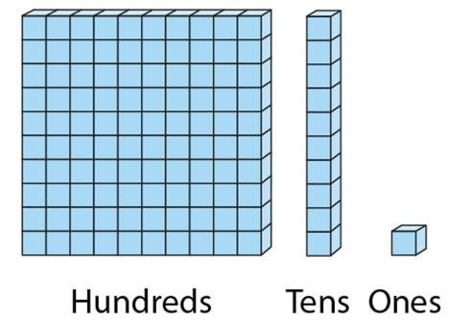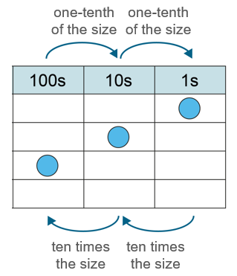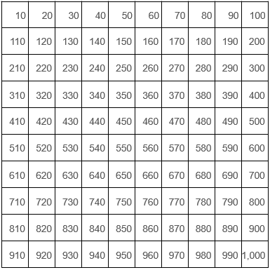

**Consider how a number increases/decreases in size using scaling models.**

***100 is ten times the size of 10.***

***10 is one-tenth the size of 100.***

***Scaling Models***

**Count in multiples of ten up to 1000.**

**Ten, Twenty, Thirty…**

**One ten, two tens, three tens…**

**Vocabulary:**

Ones Tens Hundreds Place Value Digit Represents Counters Pence Coin Tens Frame Multiple Previous Next Deines One-tenth the size Ten-times the size Centimetres Metres

**Number and Place Value**

**Year 3**

**Equivalence of 10 tens and 1 hundred (2)**

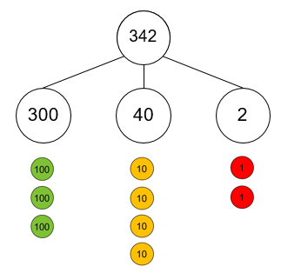

**Vocabulary:**

Ones Tens Hundreds Digit Represents Place Value Counters Partition Combine Equation Addend Sum Minuend Subtrahend Difference

**Number and Place Value**

**Year 3**

**Place Value in 3-digit numbers**

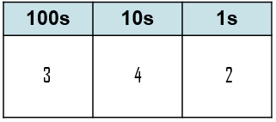

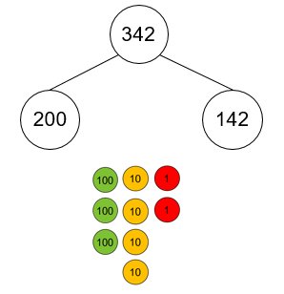

**Explore non-standard partitioning using part-part-whole models and place value counters.**

**Explain what each digit represents and give its value.**

**The 2 represents 2 ones. It has a value of 2.**

**The 4 represents 4 tens. It has a value of 40.**

**The 3 represents 3 hundreds. It has a value of 300.**

**Form 3-digit numbers using place value counters and the part-part-whole model.**

**The 2 represents 2 ones**

**The 4 represents 4 tens**

**The 3 represents 3 hundreds.**

**Write as an additive equation.**

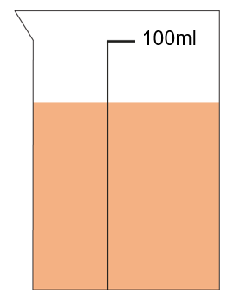

**Vocabulary:**

Ones Tens Hundreds Place Value Number line Halfway Multiples of 10

Multiples of 100 Previous Next Between

**Number and Place Value**

**Year 3**

**Three-digit numbers in the linear number system.**



**Identify the previous and next multiple of one hundred that a number sits between.**

**170 is between 100 and 200.**

**The previous multiple of 100 is 100. The next multiple of 100 is 200.**

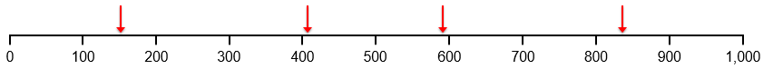

**Estimate the position of a 3 digit number number lines that are not standard.**

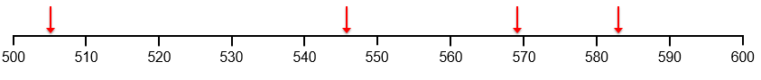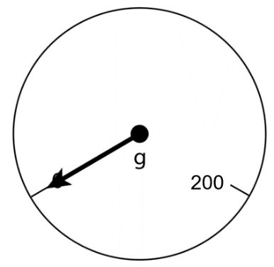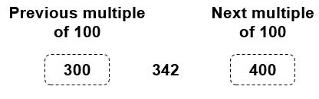

**Find previous and next multiple of 10/100 for any 3 digit number without representations.**

**Make connections between the number line and the blank number line.**

**Estimate the position of numbers of the blank number line.**

**Recognise the previous and next multiple of 10 and 100 frequently.**

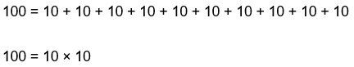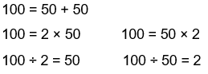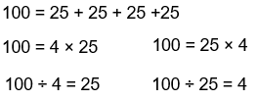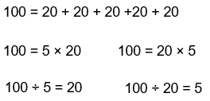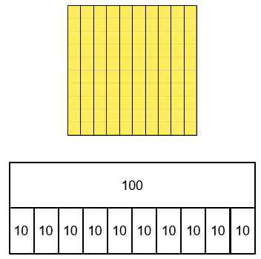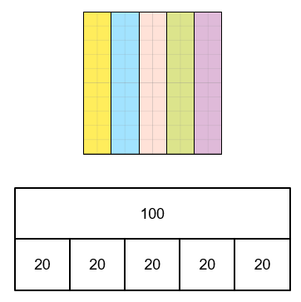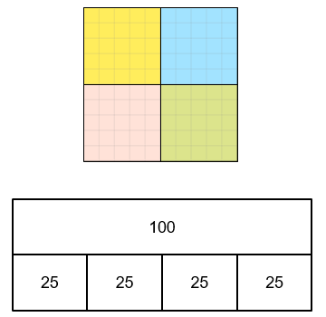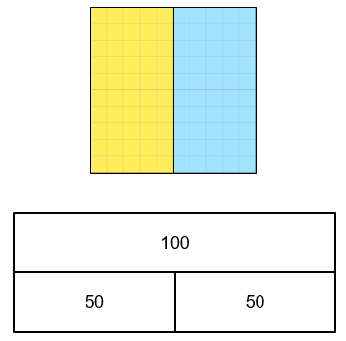

**Vocabulary:**

Intervals Scales Divisions Equal Parts Whole Value

Bar model Plus Minus Multiply Divide

**Number and Place Value**

**Year 3**

**Reading Scales with 2, 4, 5, or 10 intervals**

**Recognise common divisions of 100.**

**Record using a bar model and equations that come from this.**

**100 is divided in ___ equal parts.**

**Each part has a value of ___.**

**Vocabulary:**

Intervals Scales Divisions Equal Parts Whole Value

Bar model Plus Minus Multiply Divide

**Number and Place Value**

**Year 3**

**Reading Scales with 2, 4, 5, or 10 intervals**

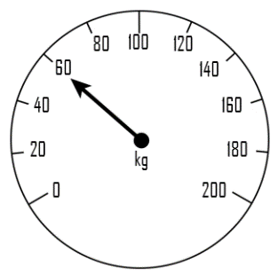

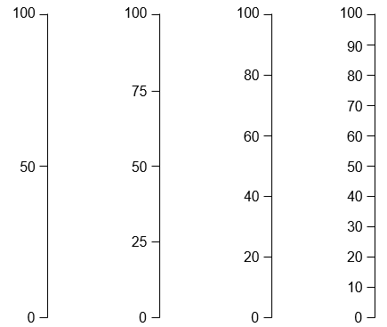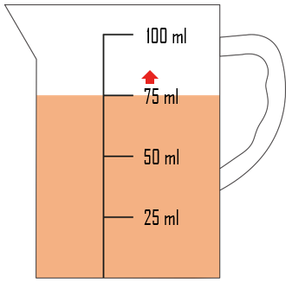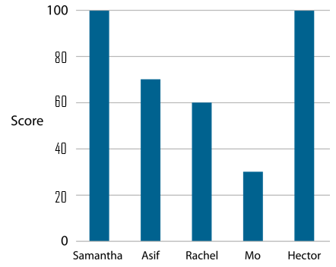

**Find the value of a scale with missing numbers and read scales with numbers included in a variety of contexts.**

**Count using these intervals in both horizontal and vertically linear scales.**

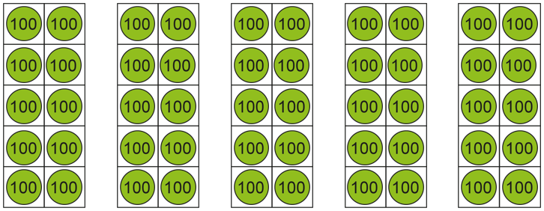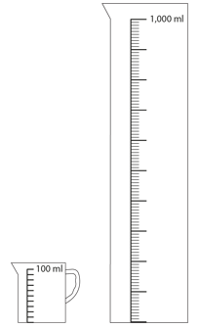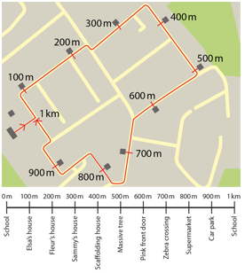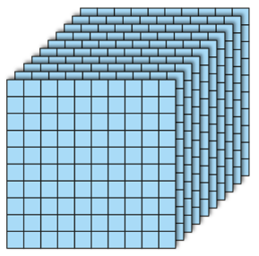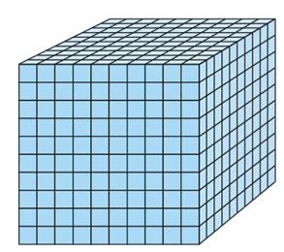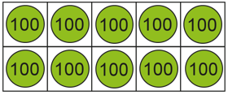

**Vocabulary:**

Ones Tens Hundreds Thousands Place Value Counters Pence Coin Tens Frame Multiple Previous Next Deines One-tenth the size Ten-times the size Centimetres Metres Millilitres Litres Grams Kilograms

**Make connections to other forms of measure eg. measuring jugs, distances.**

**Demonstrate using Deines that 10 hundreds are equal to 1 thousand.**

1,000

**Count in multiples of 100 to 1000 using Place Value Counters.**

**10 hundreds are equivalent to 1000.**

**Number and Place Value**

**Year 4**

**Equivalence of 10 hundreds and 1 thousand (1)**

**Recognise the number of hundreds in a four-digit number.**

***10 hundreds are equivalent to 1000.***

***18 hundreds are equivalent to 1800.***

**Dual count in hundreds**

***Eight hundred, nine hundred, one thousand, one thousand one hundred….***

***Eight hundred, nine hundred, ten hundreds, eleven hundreds…***

*C*

***Grouping and Exchanging Models***

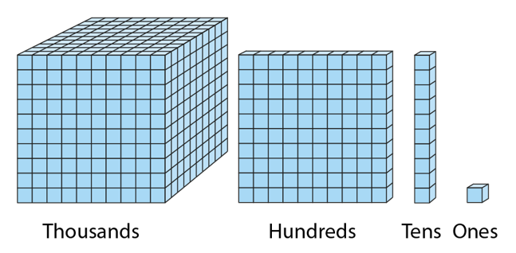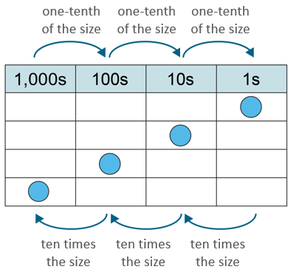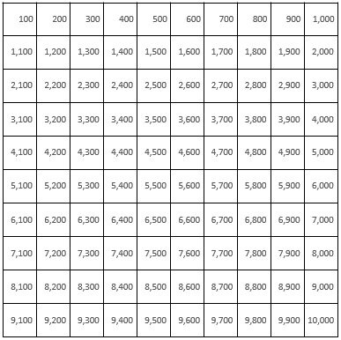

**Vocabulary:**

Ones Tens Hundreds Thousands Place Value Counters Pence Coin Tens Frame Multiple Previous Next Deines One-tenth the size Ten-times the size Centimetres Metres Millilitres Litres Grams Kilograms

***Scaling Models***

**Consider how a number increases/decreases in size using scaling models.**

***1000 is ten times the size of 100.***

***100 is one-tenth the size of 1000.***

**Count in multiples of hundred up to 1000.**

***Eight hundred, nine hundred, one thousand, one thousand one hundred….***

***Eight hundred, nine hundred, ten hundreds, eleven hundreds…***

**Number and Place Value**

**Year 4**

**Equivalence of 10 hundreds and 1 thousand (2)**

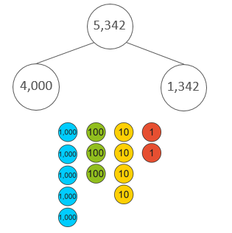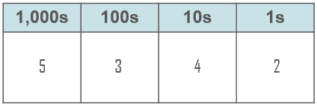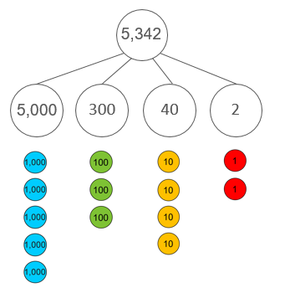

**Vocabulary:**

Ones Tens Hundreds Thousands Digit Represents Place Value Counters Partition Combine Equation Addend Sum Minuend Subtrahend Difference

**Explore non-standard partitioning using part-part-whole models and place value counters.**

**Explain what each digit represents and give its value.**

**The 2 represents 2 ones. It has a value of 2.**

**The 4 represents 4 tens. It has a value of 40.**

**The 3 represents 3 hundreds. It has a value of 300.**

**The 5 represents 5 thousands**

**Form 4-digit numbers using place value counters and the part-part-whole model.**

**The 2 represents 2 ones**

**The 4 represents 4 tens**

**The 3 represents 3 hundreds.**

**The 5 represents 5 thousands**

**Write as an additive equation.**

**Number and Place Value**

**Year 4**

**Place Value in 4-digit numbers**



**Vocabulary:**

Ones Tens Hundreds Thousands Place Value Number line Halfway Multiples of 100/1000 Previous Next Between Round Greater than

Less than Grams Millilitres Estimate

**Number and Place Value**

**Year 4**

**Four-digit numbers in the linear number system (1)**

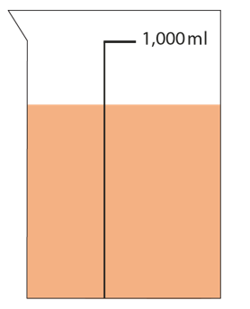

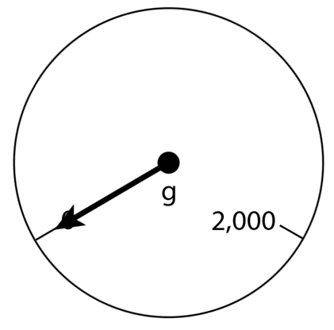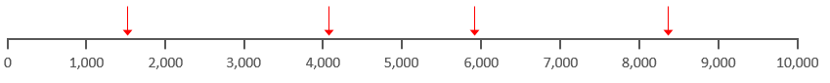

**Estimate the position of a 3 digit number number lines that are contextualised.**

**Make connections between the number line and the blank number line.**

**Estimate the position of numbers of the blank number line.**

**Recognise the previous and next multiple of 10 and 100 frequently.**

**Identify the previous and next multiple of one thousand that a number sits between.**

**3200 is between 3000 and 4000.**

**The previous multiple of 1000 is 3000. The next multiple of 1000 is 4000.**

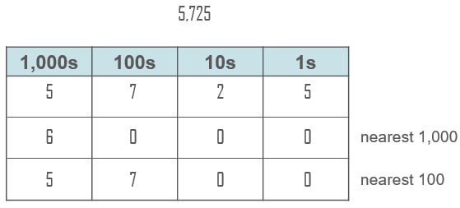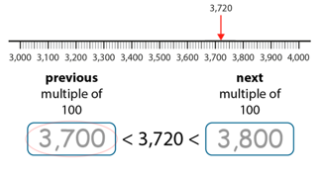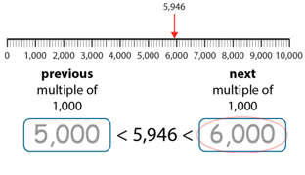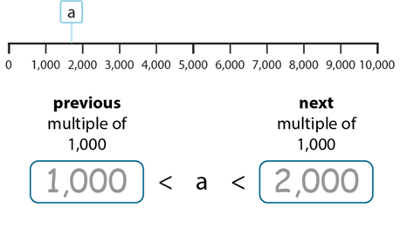

**Vocabulary:**

Ones Tens Hundreds Thousands Place Value Number line Halfway Multiples of 100/1000 Previous Next Between Round Greater than

Less than Estimate

**Round to the nearest 1000 and nearest 100.**

**Build towards finding the previous and next multiple of 100/1000 for any 4-digit number without representations.**

***The previous multiple of 1,000 is __.***

***The next multiple of 1,000 is __.***

***a is greater than ___ and less than ___.***

***a is nearest to ___ .***

**Number and Place Value**

**Year 4**

**Four-digit numbers in the linear number system (2)**

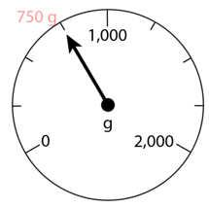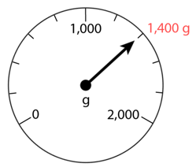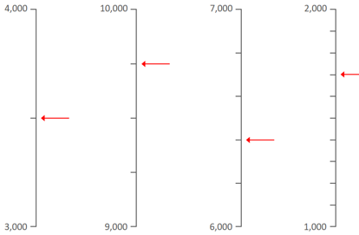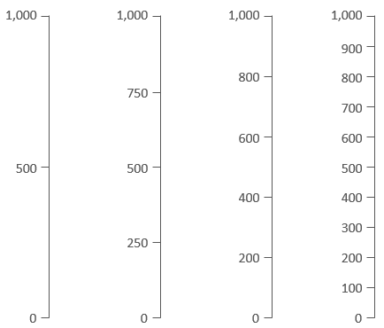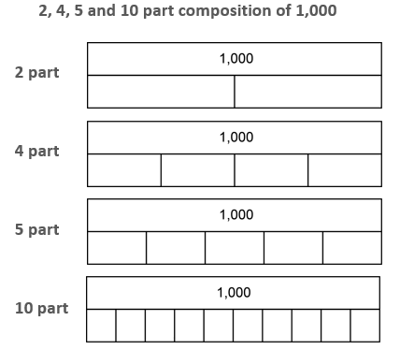

**Use the number of intervals given to find values in other contexts (e.g. weighing scales/bar graphs)**

**Use the number of intervals given to find the numbers that the arrows are pointing to.**

**Identify intervals and count forwards/backwards using these intervals with both bar models and vertical number lines.**

**Vocabulary:**

Intervals Scales Divisions Equal Parts Whole Value

Bar model Plus Minus Multiply Divide Bar graph Grams

**Number and Place Value**

**Year 4**

**Reading scales with intervals of 2, 4, 5 or 10.**

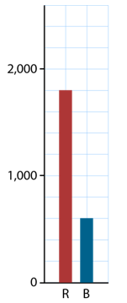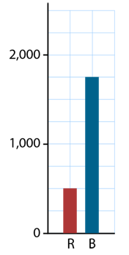

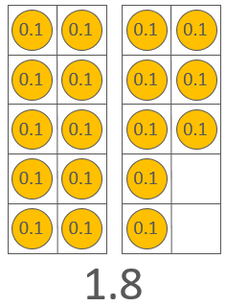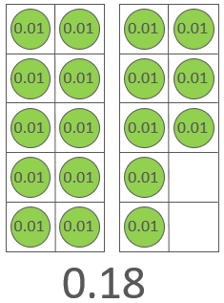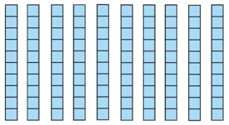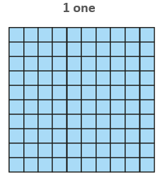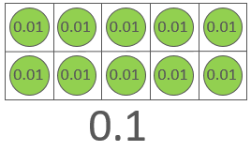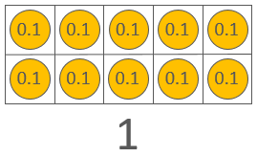

**Vocabulary:**

Ones Tens Tenths Hundredths Place Value Counters Pence Coin Tens Frame Multiple Previous Next Deines One-tenth the size Ten-times the size Centimetres Metres

**Recognise the number of tenths and hundredths**

***18 tenths are equivalent to 1.8***

***18 hundredths are equivalent to 0.18***

**Dual count in tenths and hundredths**

***Eight tenths, nine tenths, ten tenths, eleven tenths…***

***0.8, 0.9, 1.0, 1.1***

***Eight hundredths, nine hundredths, ten hundredths, eleven hundredths…***

***0.08, 0.09, 0.10, 0.11***

*C*

**=**

**One tenth is equal to ten hundredths.**

**One (whole) is equal to ten tenths.**

**=**

**Ten hundredths are equal to one tenth.**

**Ten tenths are equal to one (whole).**

**Number and Place Value**

**Year 5**

**Tenths and Hundredths**

***Grouping and Exchanging Models***

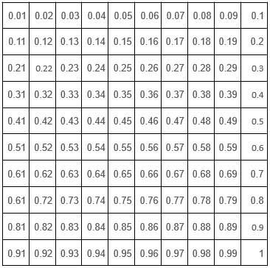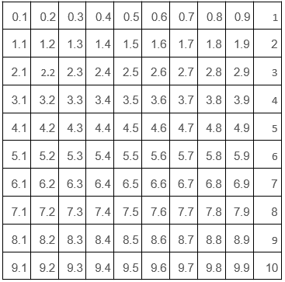

**Vocabulary:**

Ones Tens Tenths Hundredths Place Value Counters Pence Coin Tens Frame Multiple Previous Next Deines One-tenth the size Ten-times the size Centimetres Metres

**Number and Place Value**

**Year 5**

**Tenths and Hundredths (2)**

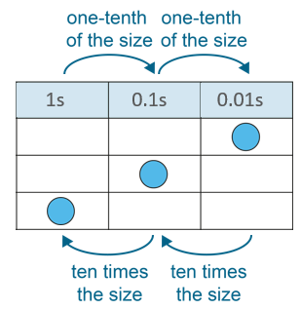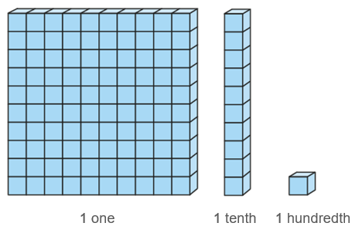

**Consider how a number increases/decreases in size using scaling models.**

***1 is ten times the size of 0.1.***

***0.1 is one-tenth the size of 1.***

***Scaling Models***

**Count in multiples of tenths and hundredths.**

***Eight tenths, nine tenths, ten tenths, eleven tenths…***

***0.8, 0.9, 1.0, 1.1***

***Eight hundredths, nine hundredths, ten hundredths, eleven hundredths…***

***0.08, 0.09, 0.10, 0.11***

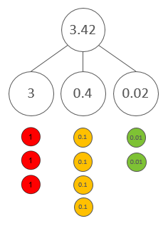

**Vocabulary:**

Ones Tens Tenths Hundredths Represents Digit Place Value Counters Partition Combine Equation Addend Sum Minuend Subtrahend Difference

**Number and Place Value**

**Year 5**

**Place Value in decimal fractions**

**Form decimal fractions using place value counters and the part-part-whole model.**

**The 2 represents 2 hundredths**

**The 4 represents 4 tenths**

**The 3 represents 3 ones.**

**Write as an additive equation.**

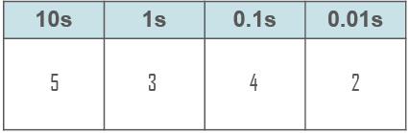

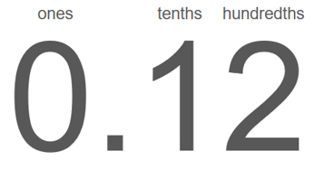

**Skip count in one-hundredths recognising the number of hundredths in a 2-digit decimal fraction.**

**Represent on a Place Value Chart and describe each value.**

**The digit in the tens place is 5. It has a value of 50.**

**The digit in the ones place is 3. It has a value of 3.**

**The digit in the tenths place is 4. It has a value of 0.4.**

**The digit in the hundredths place is 2. It has a value of 0.02.**

**.**

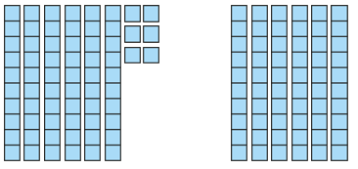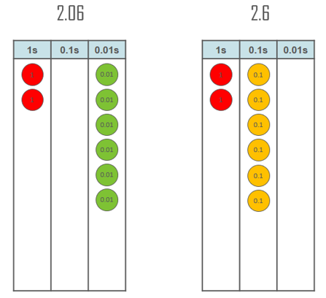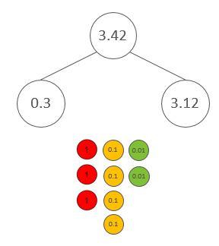

**Compare decimal fractions using deines, place value counters and a place value chart.**

**Explore non-standard partitioning using part-part-whole models and place value counters.**

**Number and Place Value**

**Year 5**

**Place Value in decimal fractions**

**Vocabulary:**

Ones Tens Tenths Hundredths Represents Digit Place Value Counters Partition Combine Equation Addend Sum Minuend Subtrahend Difference

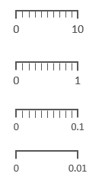

**Vocabulary:**

Ones Tens Hundreds Thousands Place Value Number line Halfway Multiples of 100/1000 Previous Next Between Round Greater than

Less than Estimate

**Number and Place Value**

**Year 5**

**Decimal Fractions in the Linear Number System**

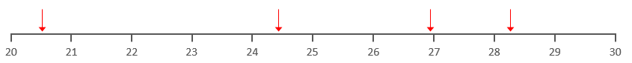

**Estimate the value of an arrow on a blank number line split into ones.**

**Recognise the value of a position on a number line split into tenths.**

**The arrow is pointing to 5.4 because it is 4 one-tenth intervals after 5 and because it is 1 one-tenth interval before the halfway point between 5 and 6.**

**Recognise the intervals found between on each number line.**



**Vocabulary:**

Ones Tens Hundredths Tenths Place Value Number line Halfway Previous Next Multiple of… Between Round Greater than

Less than Grams Millilitres Litres Grams Kilograms Metres Centimetres Estimate Round

**Number and Place Value**

**Year 5**

**Decimal Fractions in the Linear Number System (1)**

**Recognise the value of a position on a number line split into hundredths.**

**Estimate the value of an arrow on a blank number line split into tenths.**

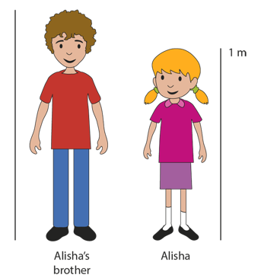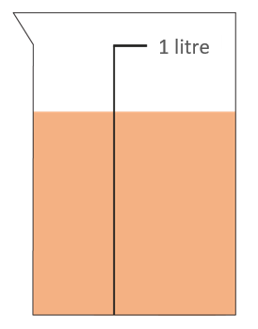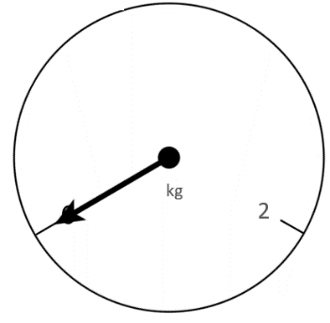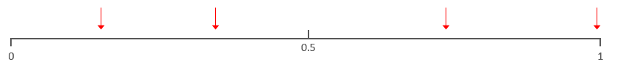

**Estimate a value when given one known value.**

**Estimate the position of a 3 digit number number lines that contextualised.**

**Estimate the value of an arrow on a blank number line.**

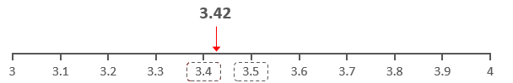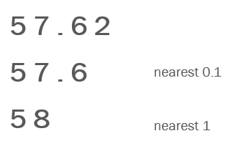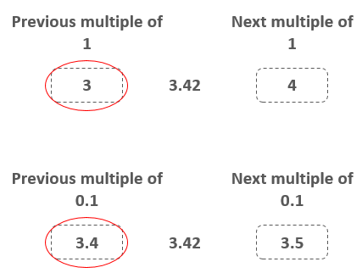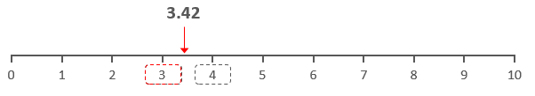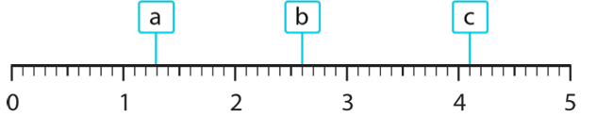

**Generalise which digit you need to look at in order to round to the nearest 1 and nearest tenth.**

**Identify the previous and next multiple of 1 that a value sits between.**

**Round to the nearest 1 and nearest tenth.**

***The previous multiple of 1 is __.***

***The next multiple of 1 is __.***

***a is greater than ___ and less than ___.***

***a is nearest to ___ .***

**Number and Place Value**

**Year 5**

**Decimal Fractions in the Linear Number System (2)**

**Vocabulary:**

Ones Tens Hundredths Tenths Place Value Number line Halfway Previous Next Multiple of… Between Round Greater than

Less than Grams Millilitres Litres Grams Kilograms Metres Centimetres Estimate Round

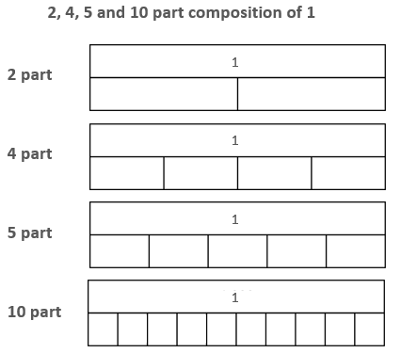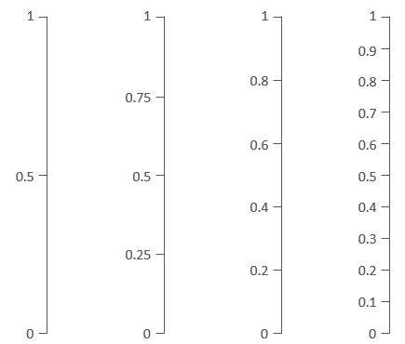

**Vocabulary:**

Intervals Scales Divisions Equal Parts Whole Value

Bar model Plus Minus Multiply Divide Grams Millilitres Litres Grams Kilograms Metres Centimetres Estimate

**Number and Place Value**

**Year 5**

**Reading Scales with 2, 4, 5, or 10 intervals**

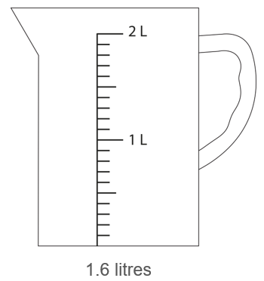

**Use the number of intervals given to find values in other contexts (e.g. weighing scales/bar graphs)**

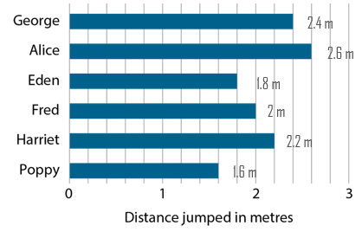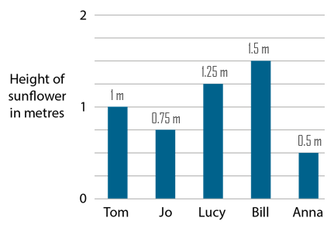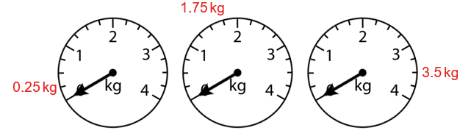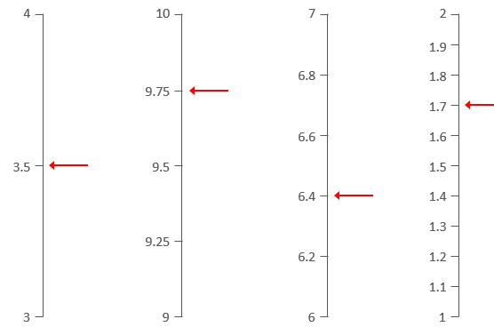

**Use the number of intervals given to find the numbers that the arrows are pointing to.**

**Identify intervals and count forwards/backwards using these intervals with both bar models and vertical number lines.**

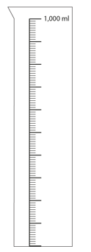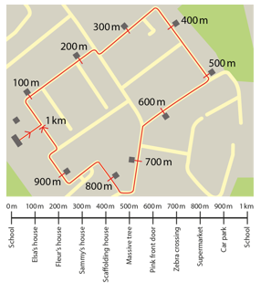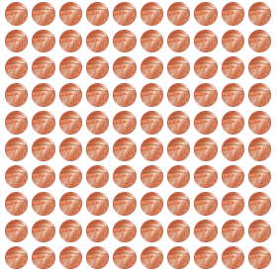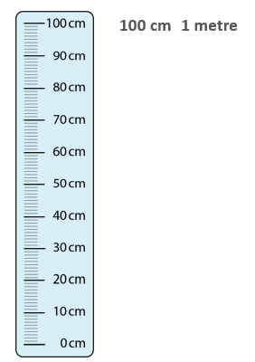

**Recognise that 1000ml is equivalent to 1L.**

**Practice counting forwards and backwards along the scale.**

**1 litre is equivalent to 1000 millilitres.**

**Recognise that 1000m is equivalent to 1km.**

**Practice counting forwards and backwards along the scale.**

**1 kilometre is equivalent to 1000 metres.**

**Recognise that 100p is equivalent to £1.**

**Practice counting forwards and backwards along the scale.**

**1 pound is equivalent to 100 pence.**

**Recognise that 10 lots of 10cm is equivalent to 1m.**

**Practice counting forwards and backwards along the scale.**

**1 metre is equivalent to 100 centimetres.**

**Vocabulary:**

Intervals Scales Divisions Equal Parts Whole Value

Bar model Plus Minus Multiply Divide Grams Millilitres Litres Grams Kilograms Metres Centimetres Estimate

**Number and Place Value**

**Year 5**

**Convert between Units of Measure**

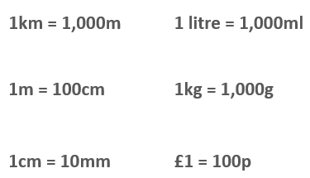

**Vocabulary:**

Conversions Pounds Pence Grams Millilitres Litres Grams Kilograms Metres Centimetres Decimal Fraction Whole Number Multiple Divide

**Number and Place Value**

**Year 5**

**Convert between Units of Measure**

**Make connections from the conversions to larger numbers.**

**If 1km = 1000m, then 3km = ______.**

**These conversions must be memorised. Practice recall of these conversions over time.**

*P*

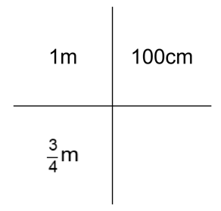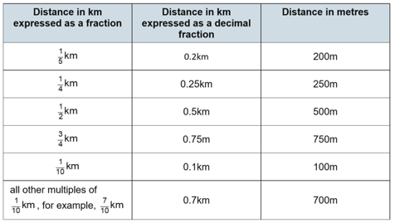

**Recognise how units can be converted between fractions, decimals and whole numbers.**

$\frac{1}{5}$**= 0.2 so $\frac{1}{5}$ km = 0.2km**

**1km = 1,000m**

**so $\frac{1}{5}$ km = 1,000 ÷ 5 = 200m**

**Use known conversion facts to solve conversions from a fraction.**

***1m = 100 cm***

$\frac{3}{4}$***m = 75 cm***

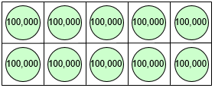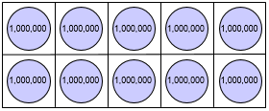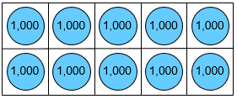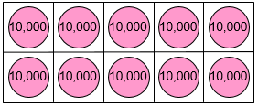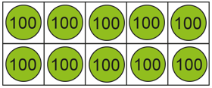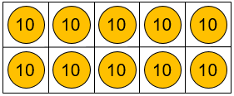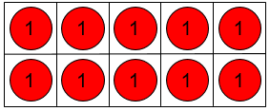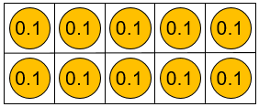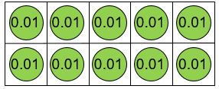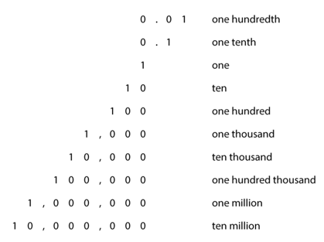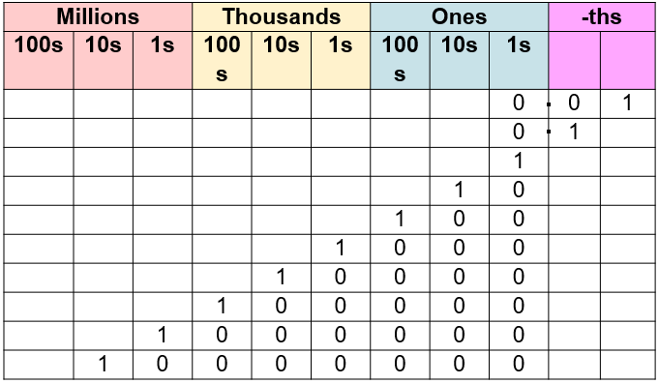

**Vocabulary:**

Ones Tens Hundreds Thousands Ten-thousands Hundred-thousands Millions Ten-Millions Tenths Hundredths Represents Digit Place Value Counters Tens Frame Equivalent Equation Multiply Divide

Ten/hundred times the size One-tenth/hundredth times the size

**Recognise that:**

**10 hundredths are equivalent to 1 tenth.**

**10 tenths are equivalent to 1 one.**

**10 ones are equivalent to 1 ten.**

**10 tens are equivalent to 1 hundred.**

**10 hundreds are equivalent to 1 thousand.**

**10 thousands are equivalent to 1 ten thousand.**

**10 ten thousands are equivalent to 1 hundred thousand.**

**10 hundred thousands are equivalent to 1 million.**

**10 millions are equivalent to 1 ten million.**

**Number and Place Value**

**Year 6**

**Powers of 10**

**Recognise that the 1 becomes ten times the size as it moves from right to left in a place value chart.**

**Recognise that 1 becomes one-tenth the size as it moves from left to right in a place value chart.**

**Recognise that the 1 becomes 10 times the size as it moves up in a chart.**

**Recognise that 1 becomes one-tenth the size as it moves down in a chart.**

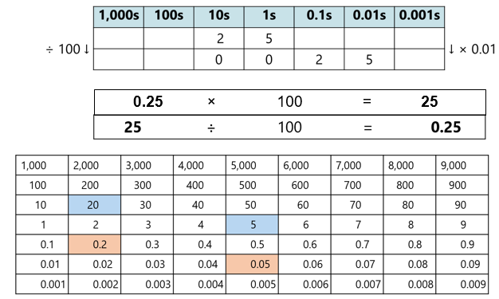

**Use the Place Value chart to support children to visualise multiplying and dividing by 10, 100 or 1000.**

**25 is one hundred times the size of 0.25. 0.25 multiplied by 100 is equal to 25.**

**0.25 is one-hundredth of the size of 25. 25 divided by 100 is equal to 0.25.**

***Grouping and Exchanging Models***

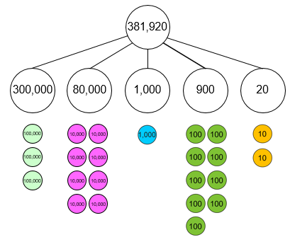

**Vocabulary:**

Ones Tens Hundreds Thousands Ten-thousands Hundred-thousands Millions Ten-Millions Tenths Hundredths Represents Digit Place Value Counters Partition Combine Equation Addend Sum Minuend Subtrahend Difference

**Number and Place Value**

**Year 6**

**Place Value in Numbers up to 10,000,000.**

**Form numbers to 10,000,000 using place value counters and the part-part-whole model.**

**The 2 represents 2 tens**

**The 9 represents 9 hundreds**

**The 3 represents 3 hundred thousands.**

**Write as an additive equation.**

+ 20

= 210,120

+ 100

200,000

+ 10,000

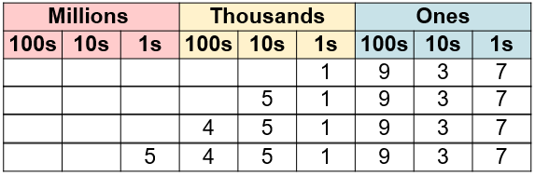

**Read numbers to 10,000,000. Focus on the structure of millions, thousands and ones.**

**5 million, four hundred and fifty one thousand, nine hundred and thirty one (ones).**

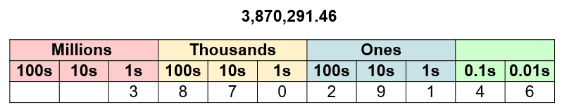

**Recognise the value of each digit.**

**The 3 represent 3 million.**

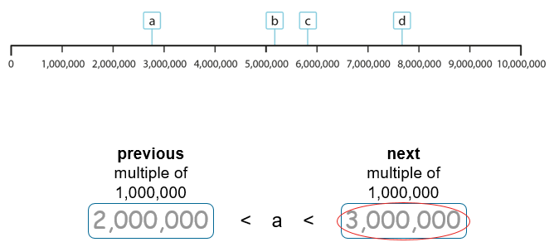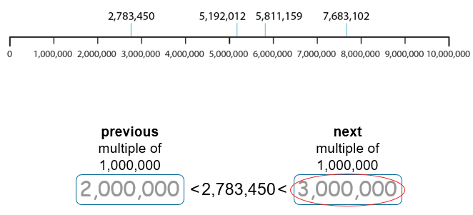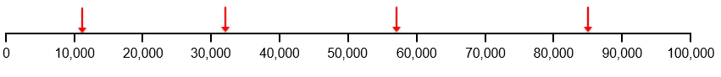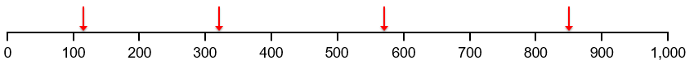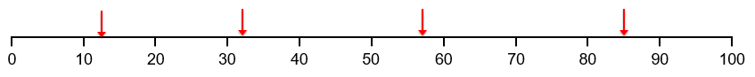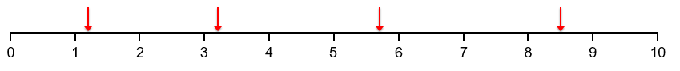

**Identify the previous and next multiple of 1,000,000 that a value sits between.**

**Round to the nearest million/hundred thousand/ten thousand.**

***The previous multiple of 1,000,000 is __.***

***The next multiple of 1,000,000 is __.***

***a is greater than ___ and less than ___.***

***a is nearest to ___ .***

**Recognise the value of a position on a number line split into ten intervals. Discuss what information children used to help identify the value.**

**Vocabulary:**

Ones Tens Hundreds Thousands Ten-thousands Hundred-thousands Millions Ten-Millions Tenths Hundredths Represents Digit Place Value Number line Halfway Previous Next Multiple of… Between Round Greater than

Less than Grams Millilitres Litres Grams Kilograms Metres Centimetres Estimate Round

**Number and Place Value**

**Year 6**

**Numbers to 10,000,000 in the Linear Number System**

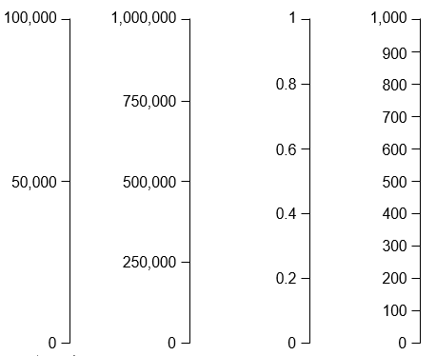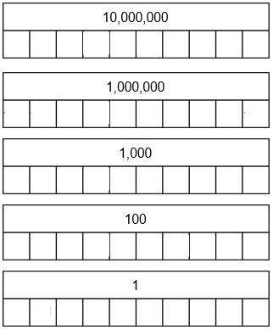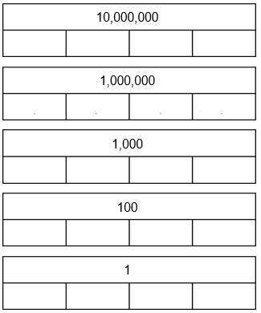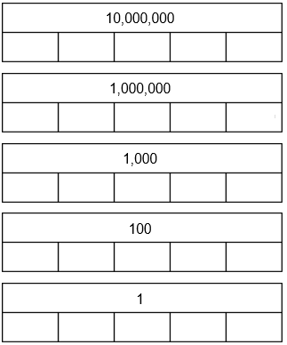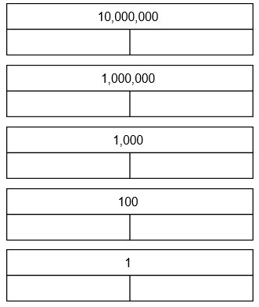

**Vocabulary:**

Ones Tens Hundreds Thousands Ten-thousands Hundred-thousands Millions Ten-Millions Tenths Hundredths Represents Digit Place Value Intervals Scales Divisions Equal Parts Whole Value Bar model Plus Minus Multiply Divide Grams Millilitres Litres Grams Kilograms Metres Centimetres Estimate

Less than Grams Millilitres Litres Grams Kilograms Metres Centimetres Estimate Round

**Number and Place Value**

**Year 6**

**Reading Scales with 2, 4, 5, or 10 intervals**

**Make connections with different wholes when dividing these into 2, 4, 5, and 10 equal parts.**

**Identify intervals and count forwards/backwards using these intervals with both bar models and vertical number lines.**

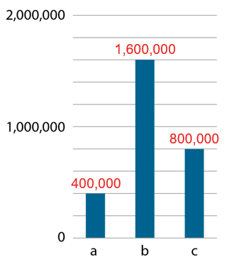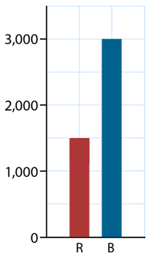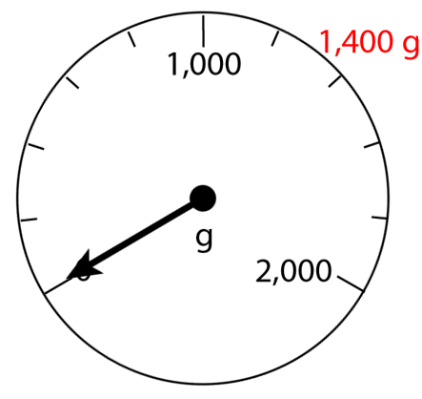

**Use the number of intervals given to find values in other contexts (e.g. weighing scales/bar graphs)**