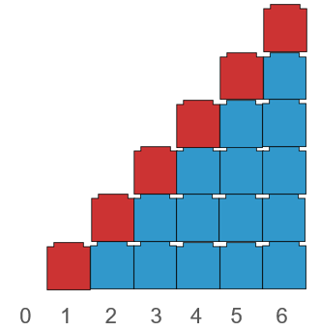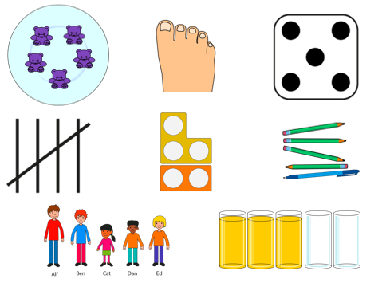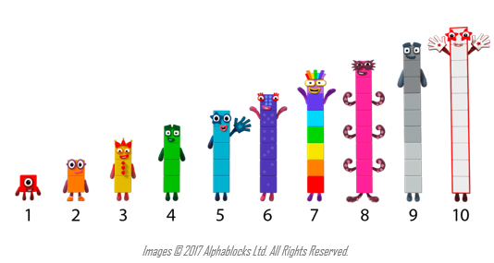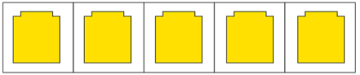

**Addition and Subtraction**

**Year 1**

**Compose and Partition Numbers to 10 (1)**

**Understand that numbers to 10 can be represented in many different ways.**

**Numbers to 5 can be identified without counting (subitising).**

**Each number is composed of the previous number and one more.**

**Vocabulary:**

Part Whole One Two Three Four Five Six Seven Eight Nine Ten Represents Compose Combine Partition Numberblocks Part-Part-Whole (Cherry) model Tens Frame Fingers Five and-a-bit Systematic Subitise One more One less

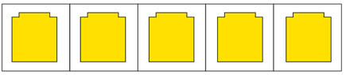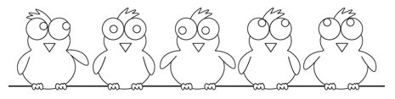





**Each number can be partitioned into two smaller numbers**

**There are 5 ____. 3 are ____. 2 are ____.**

**5 is the whole. 3 is a part. 2 is a part.**

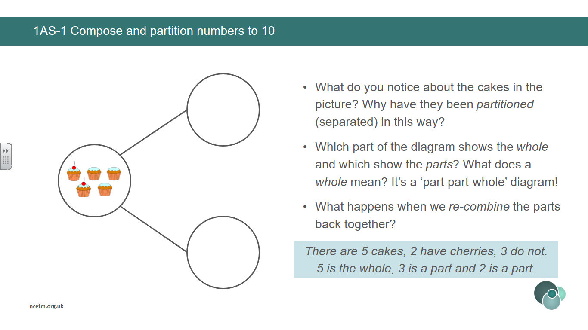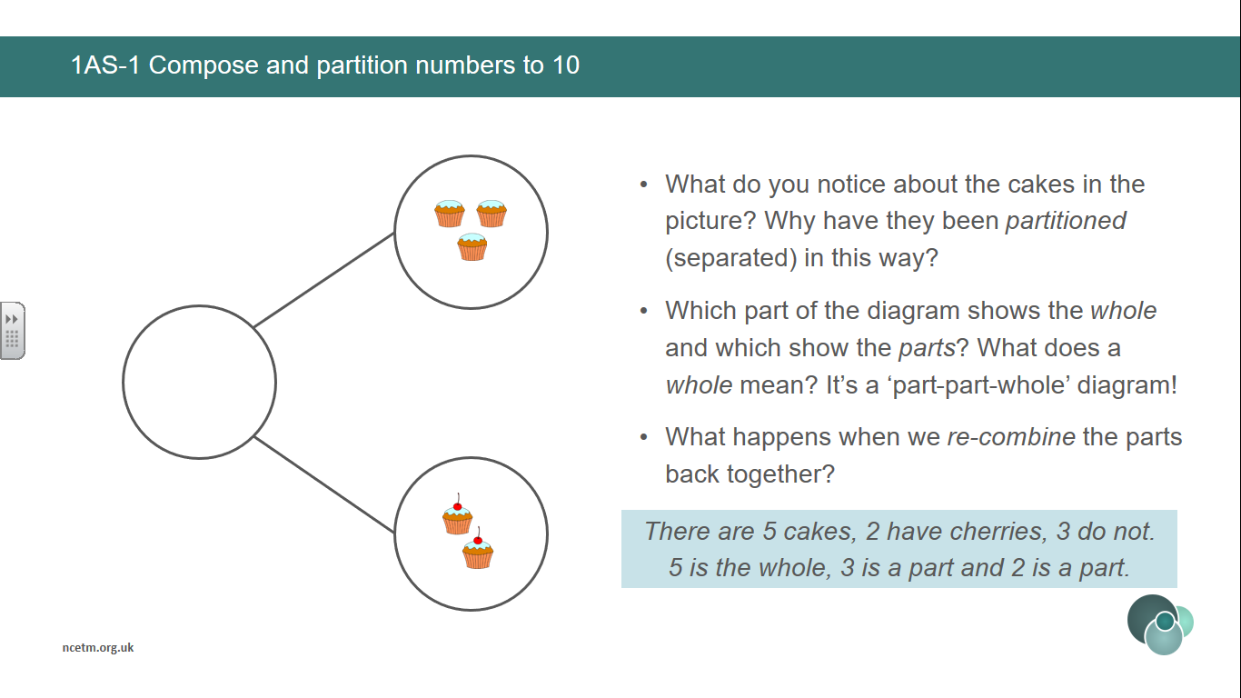

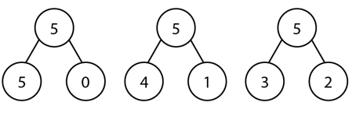

**A number can be partitioned in different ways.**

**There are 5 ____. 3 are ____. 2 are ____.**

**5 is the whole. 3 is a part. 2 is a part.**

**Vocabulary:**

Ones Tens Digit Represents Place Value Gattegno Chart Column Model Part Whole Addend Sum Minuend Subtrahend Difference Plus Minus Equals Combine Partition

**Addition and Subtraction**

**Year 1**

**Compose and Partition Numbers to 10**

**Vocabulary:**

Part Whole One Two Three Four Five Six Seven Eight Nine Ten Represents Compose Combine Partition Numberblocks Part-Part-Whole (Cherry) model Tens Frame Fingers Five and-a-bit Systematic Subitise One more One less

**Addition and Subtraction**

**Year 1**

**Compose and Partition Numbers to 10 (2)**

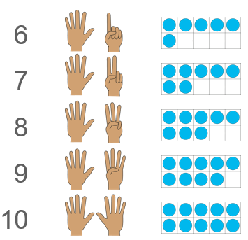

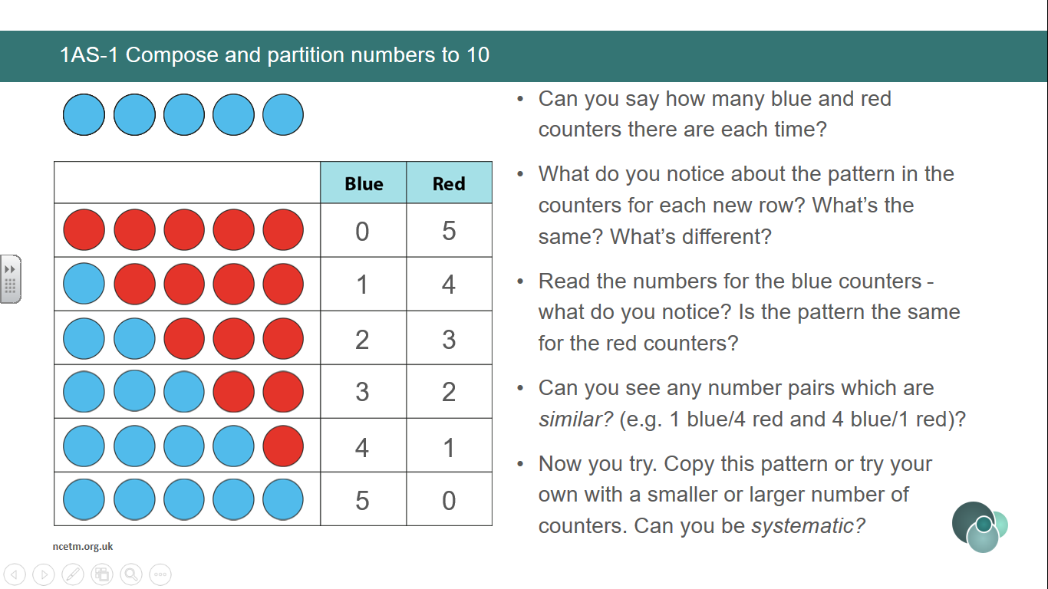

**A number can be partitioned in different ways systematically.**

**Numbers from 6 – 10 are composed of the ‘5 and a bit’ structure.**

**Vocabulary:**

Part Whole One Two Three Four Five Six Seven Eight Nine Ten Represents Compose Combine Partition Total Part-Part-Whole (Cherry) model Tens Frame Fingers Five and-a-bit Systematic Plus + Minus - Equal to = Addition Subtraction Quantity Increase Decrease First, Then, Now Expression Equation

Addend + Addend = Sum Minuend – Subtrahend = Difference

**Addition and Subtraction**

**Year 1**

**Read, Write and Interpret Additive Equations (1)**

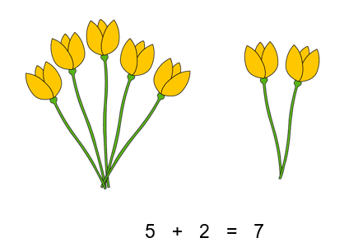

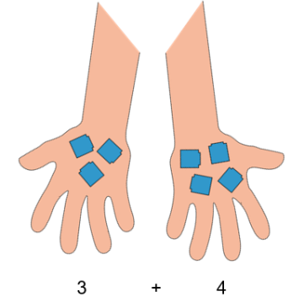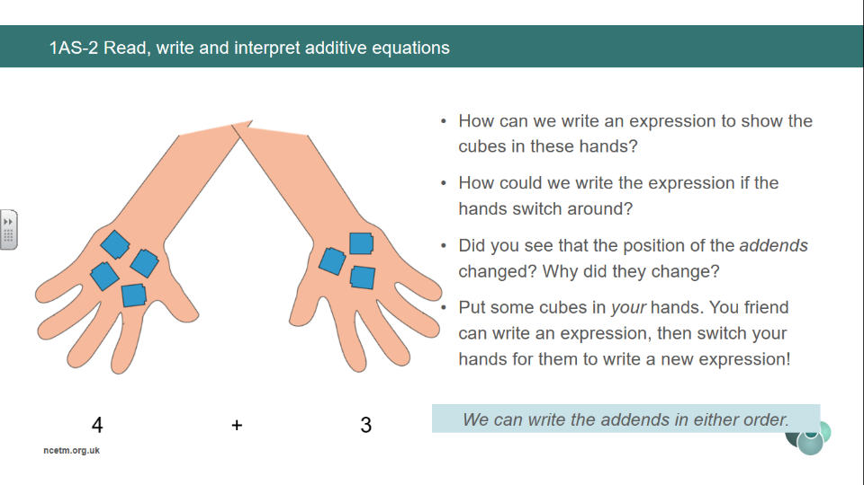

**We can write the addends in either order.**

**(Commutative Law)**

**Identify what each number represents in an expression.**

**The 4 represents the 4 yellow flowers.**

**The 3 represents the 3 red flowers.**

4

3

+

**Identify what each number represents in an expression.**

**We can write 5 plus 2 is equal to 7.**

**The 5 represents ____.**

**The 2 represents___.**

**The 7 represents the total number of ___.**

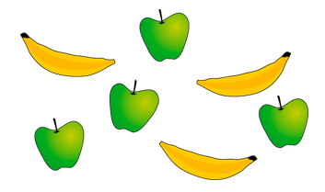

4 + 3 = 7

**Vocabulary:**

Part Whole One Two Three Four Five Six Seven Eight Nine Ten Represents Compose Combine Partition Total Part-Part-Whole (Cherry) model Tens Frame Fingers Five and-a-bit Systematic Plus + Minus - Equal to = Addition Subtraction Quantity Increase Decrease First, Then, Now Expression Equation

Addend + Addend = Sum Minuend – Subtrahend = Difference

Addend + Addend = Sum Minuend – Subtrahend = Difference

**Addition and Subtraction**

**Year 1**

**Read, Write and Interpret Additive Equations**

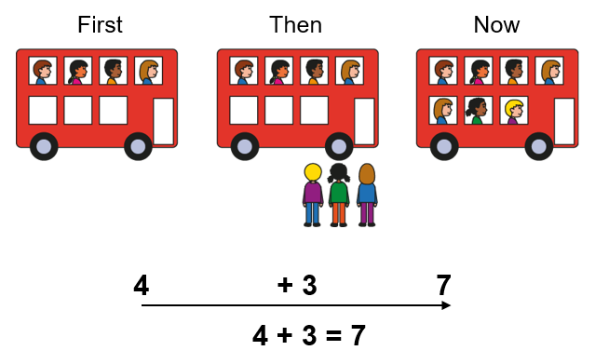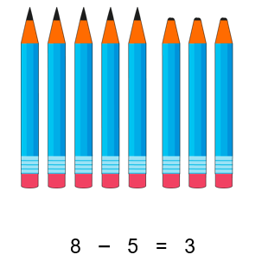

**Subtraction can tell us about partitioning.**

**There are 8 ____ altogether.**

**5 ___ are ____.**

**3 ___ are ____.**

**We can write this as 8 minus 5 is equal to 3.**

**Understand the First, Then, Now structure of addition and subtraction.**

**Addition can tell us about a quantity increasing.**

**Subtraction can tell us about a quantity decreasing.**

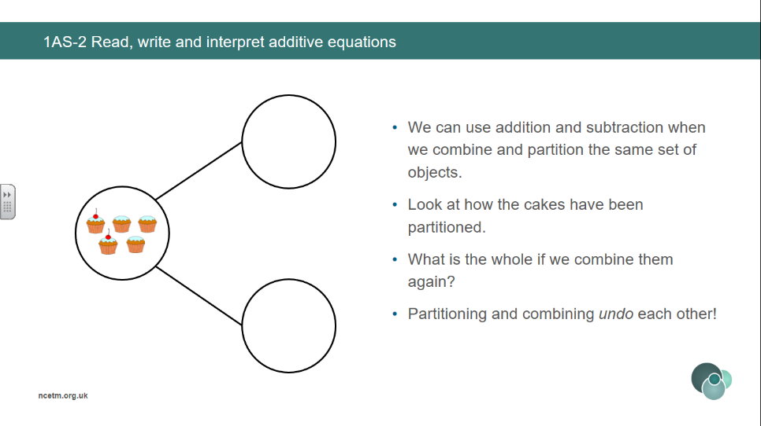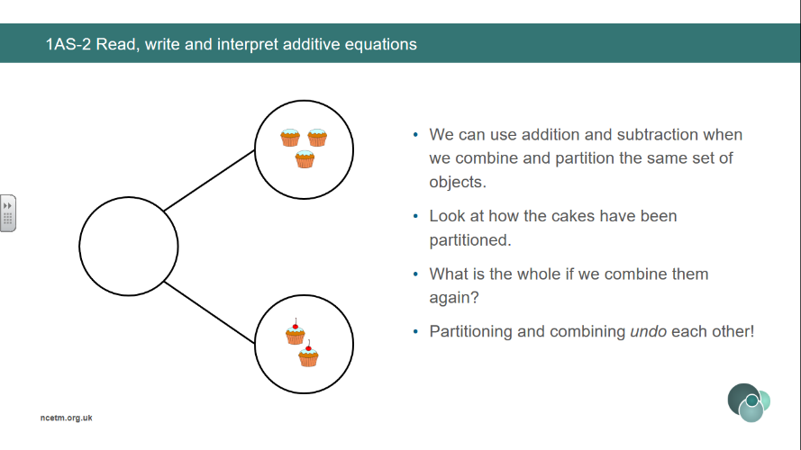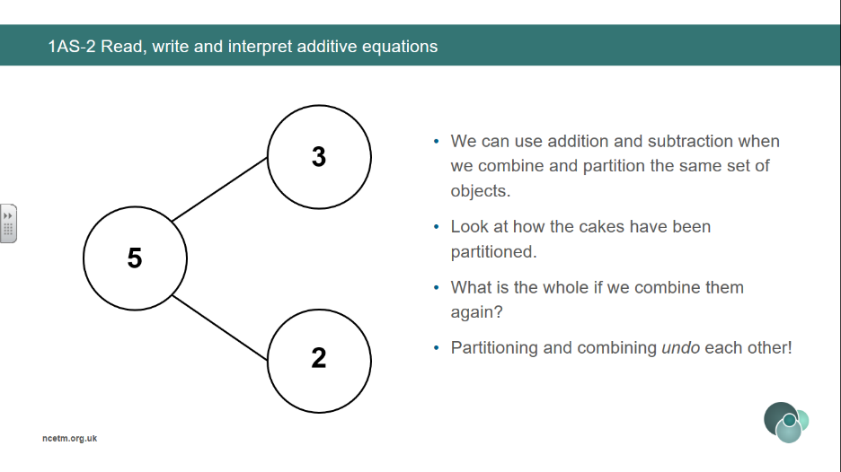

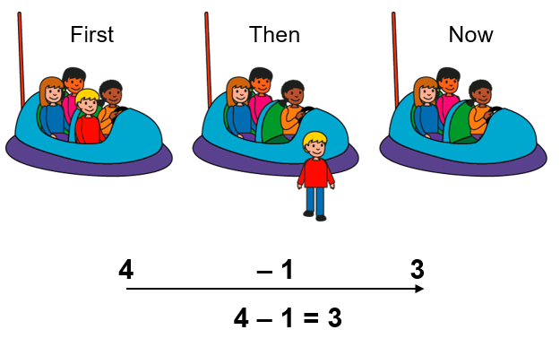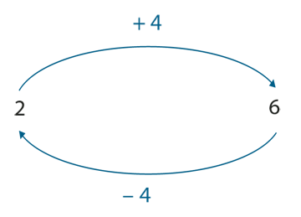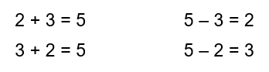

**Addition and Subtraction undo eachother.**

**Make connections between addition and subtraction using the part-part-whole model.**

**Addition can tell us about combining objects.**

**Subtraction can tell us about partitioning objects.**

**Vocabulary:**

Part Whole One Two Three Four Five Six Seven Eight Nine Ten Represents Compose Combine Partition Total Part-Part-Whole (Cherry) model Tens Frame Fingers Five and-a-bit Systematic Plus + Minus - Equal to = Addition Subtraction Quantity Increase Decrease First, Then, Now Expression Equation

Addend + Addend = Sum Minuend – Subtrahend = Difference

Addend + Addend = Sum Minuend – Subtrahend = Difference

**Addition and Subtraction**

**Year 2**

**Add and Subtract across 10 (1)**

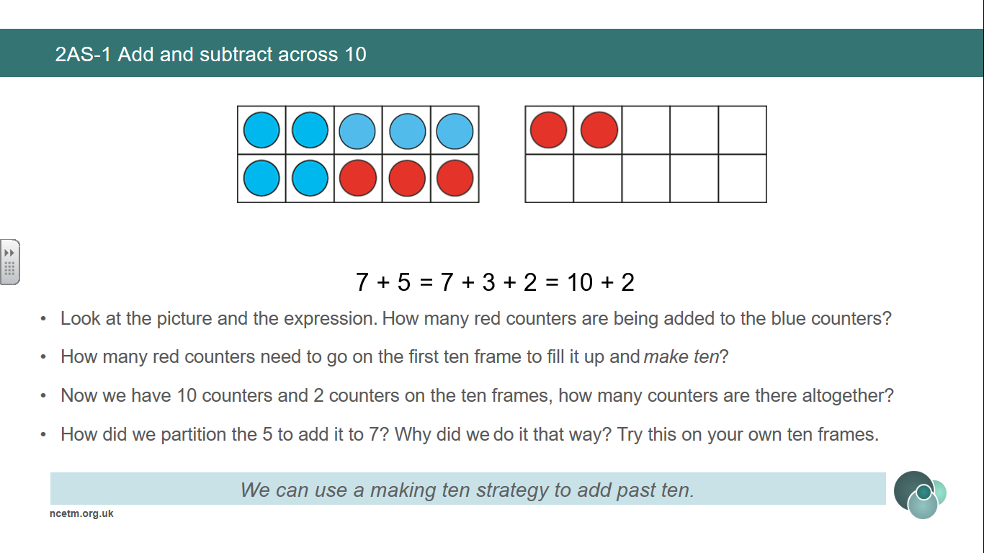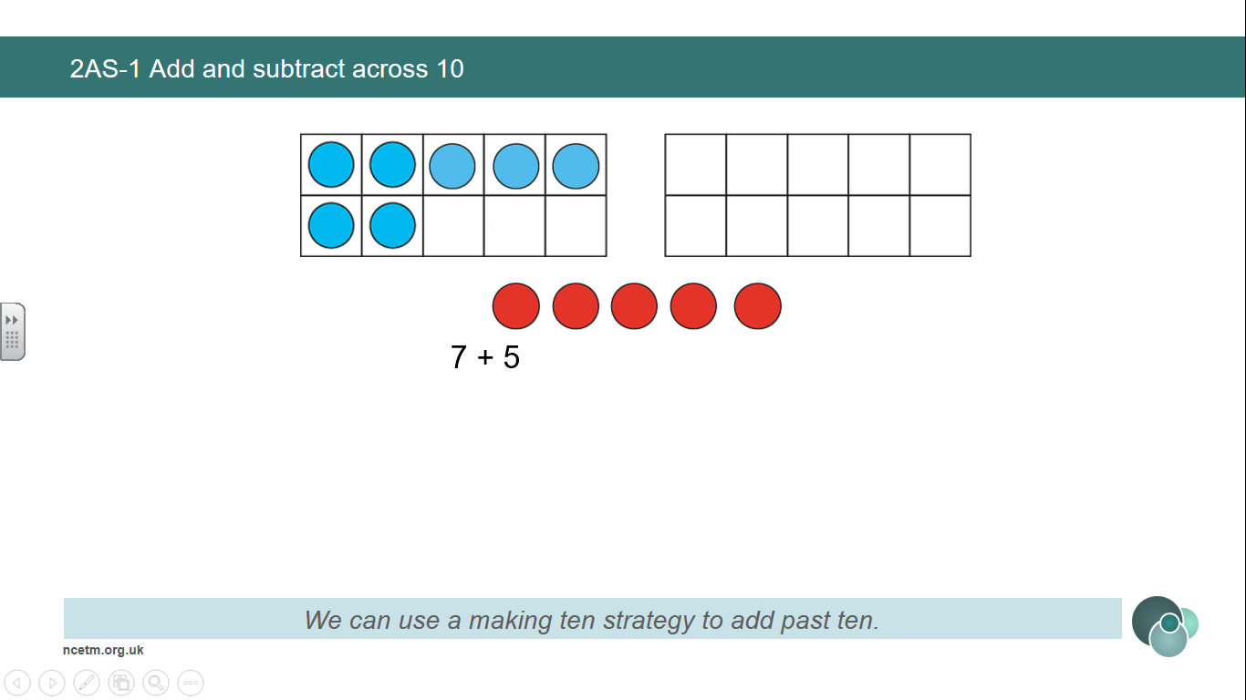

**Use knowledge of known facts to bridge 10 using a ‘make 10’ strategy.**

**First, I partition the __ into ___ and ___.**

**Then, I add ___ and ___ to make 10.**

**Then, I add the remaining ___ to make ___.**

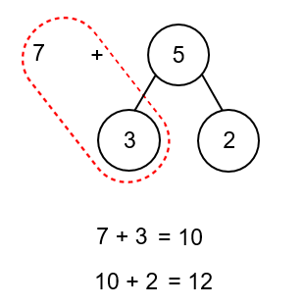

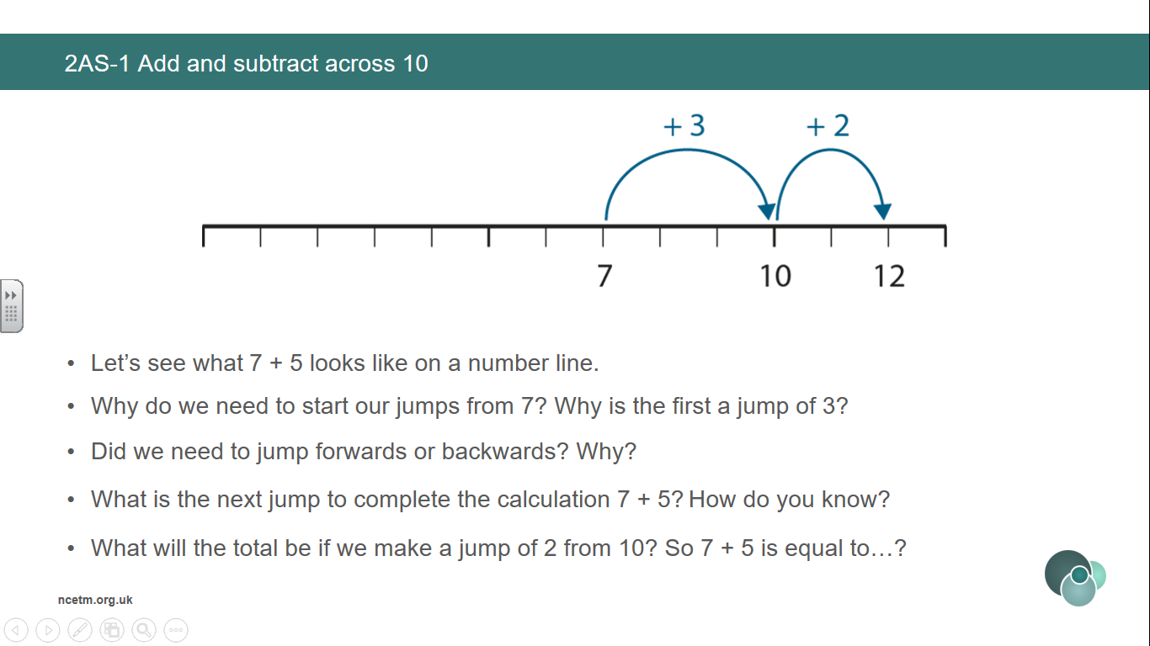

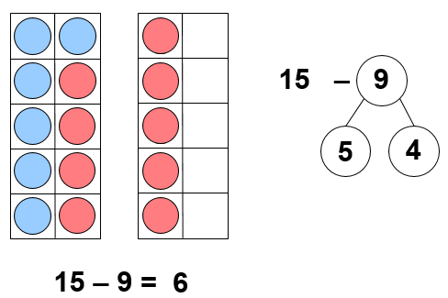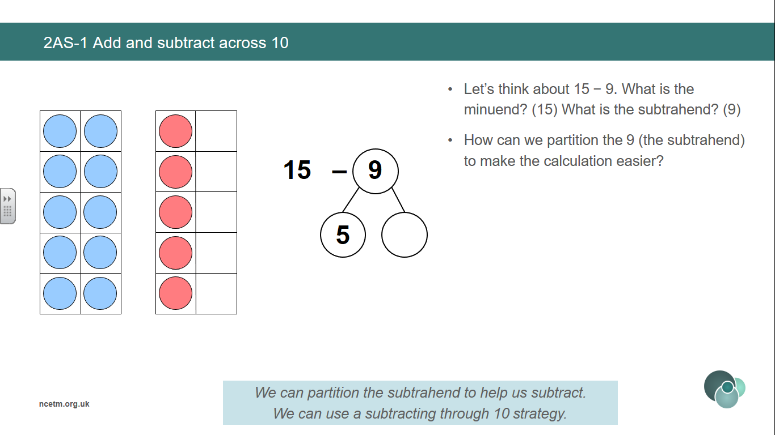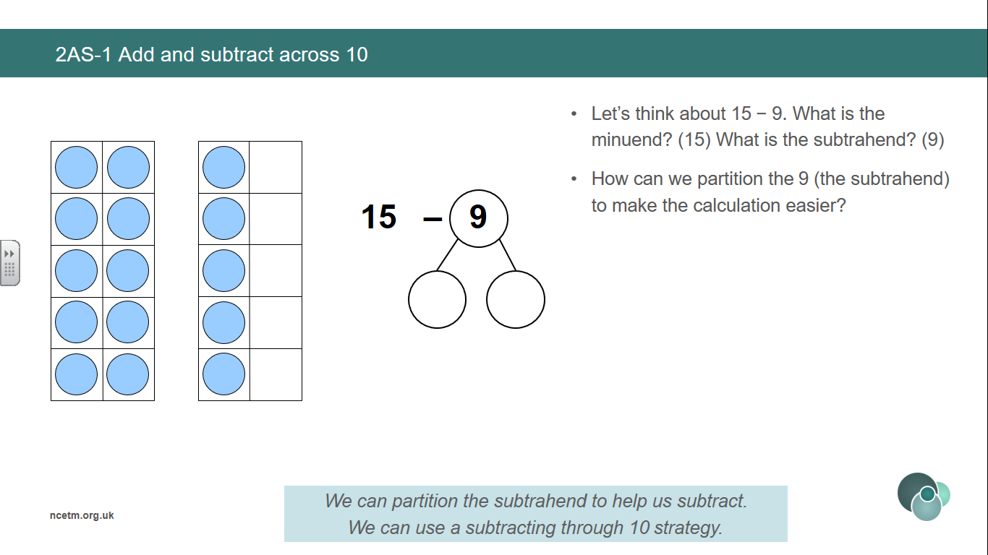

**Vocabulary:**

Part Whole One Two Three Four Five Six Seven Eight Nine Ten Represents Compose Combine Partition Total Part-Part-Whole (Cherry) model Tens Frame Fingers Five and-a-bit Systematic Plus + Minus - Equal to = Addition Subtraction Quantity Increase Decrease First, Then, Now Expression Equation

Addend + Addend = Sum Minuend – Subtrahend = Difference

Addend + Addend = Sum Minuend – Subtrahend = Difference

**Addition and Subtraction**

**Year 2**

**Add and Subtract across 10 (2)**

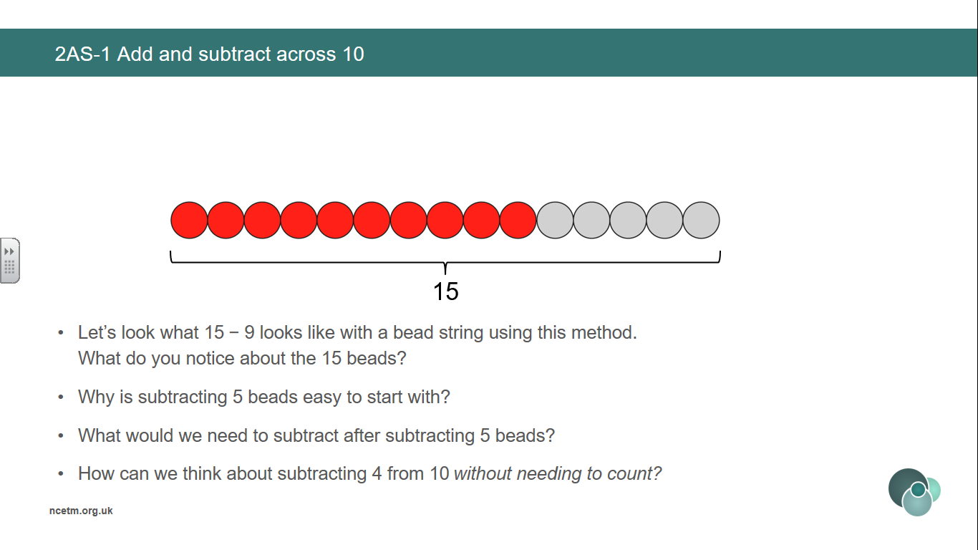

**Use knowledge of known facts to subtract *through 10*. We can partition the subtrahend to help us subtract.**

**First, I partition the __ into ___ and ___.**

**Then, I subtract ___ and ___ to get to 10.**

**Then, I subtract the remaining ___ to make ___.**

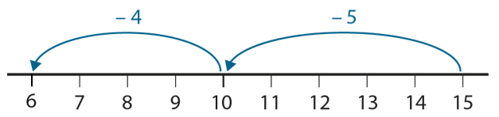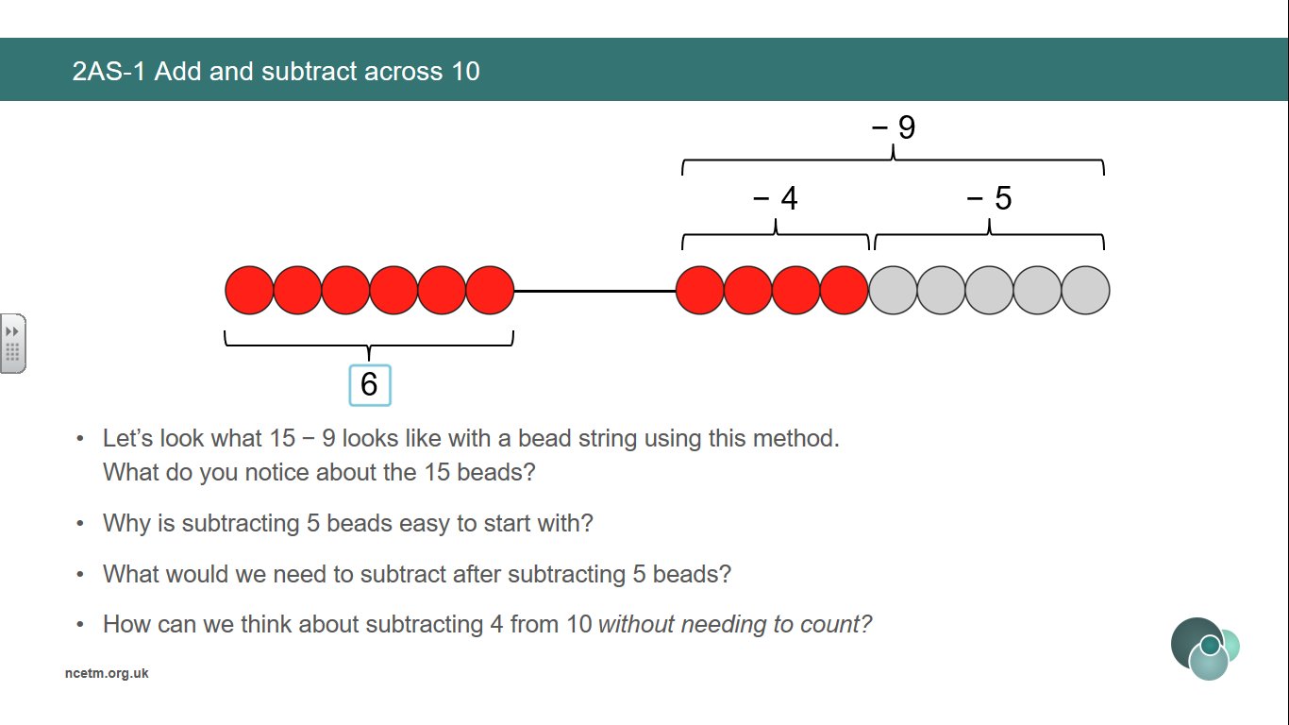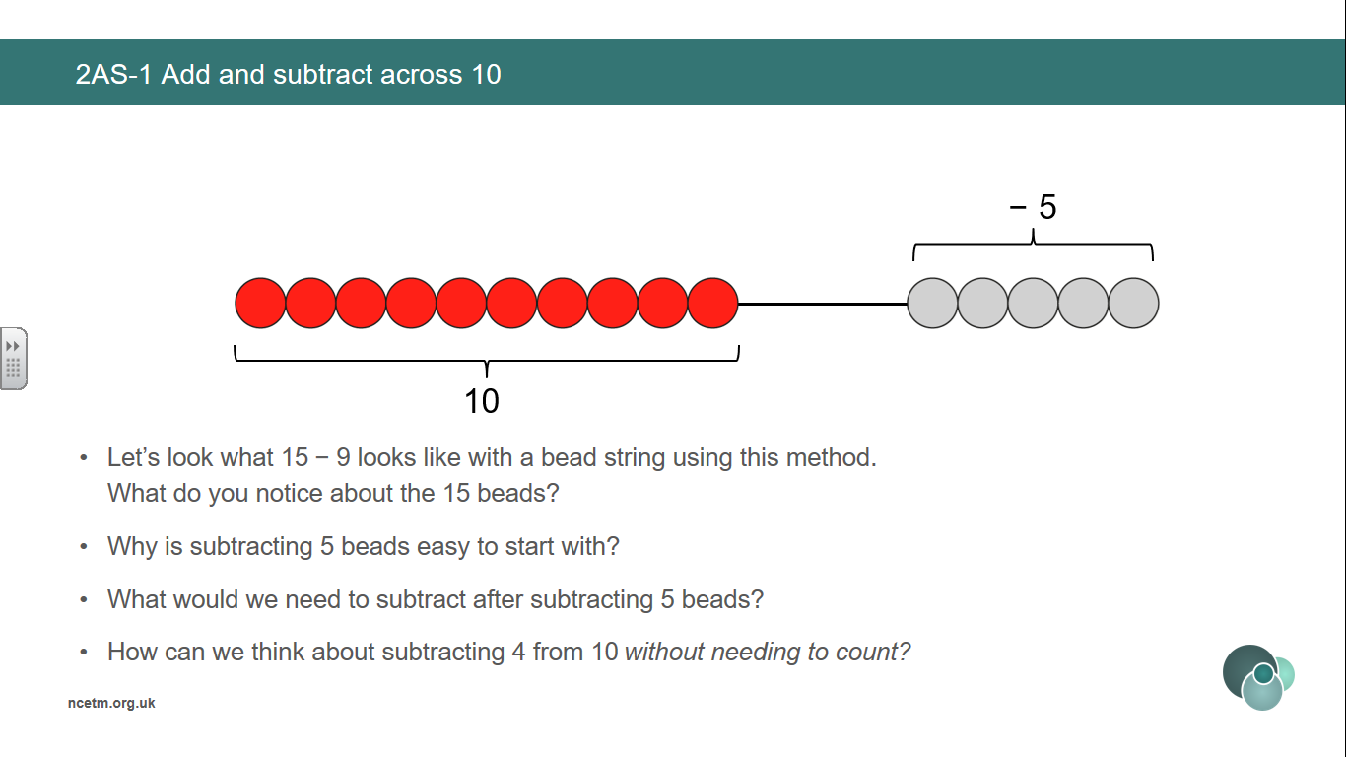

**Vocabulary:**

Part Whole One Two Three Four Five Six Seven Eight Nine Ten Represents Compose Combine Partition Total Part-Part-Whole (Cherry) model Tens Frame Fingers Five and-a-bit Systematic Plus + Minus - Equal to = Addition Subtraction Quantity Increase Decrease First, Then, Now Expression Equation

Addend + Addend = Sum Minuend – Subtrahend = Difference

Addend + Addend = Sum Minuend – Subtrahend = Difference

**Addition and Subtraction**

**Year 2**

**Add and Subtract across 10 (3)**

**Use knowledge of known facts to subtract *from 10*. We can partition the subtrahend to help us subtract.**

**First, I partition the __ into ___ and ___.**

**Then, I subtract ___ from 10 to make ___.**

**Then, I add the remaining ___ to make ___.**

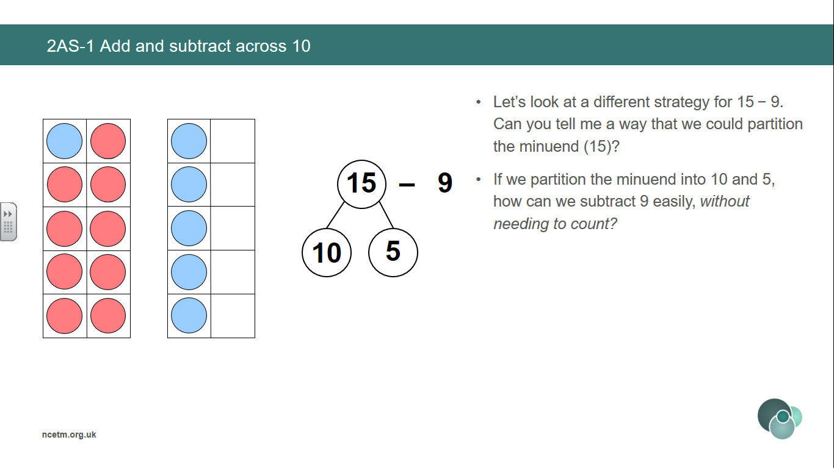

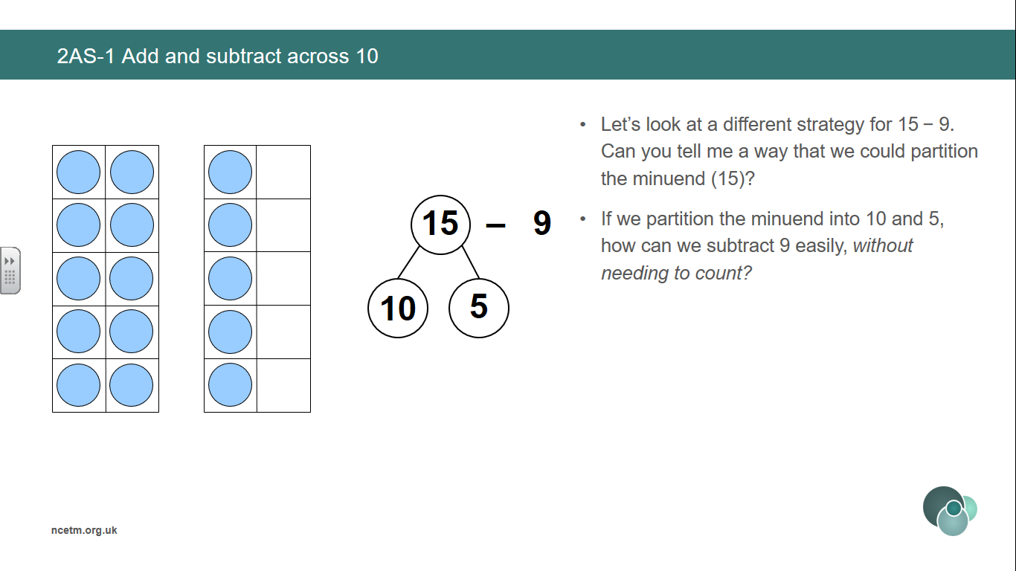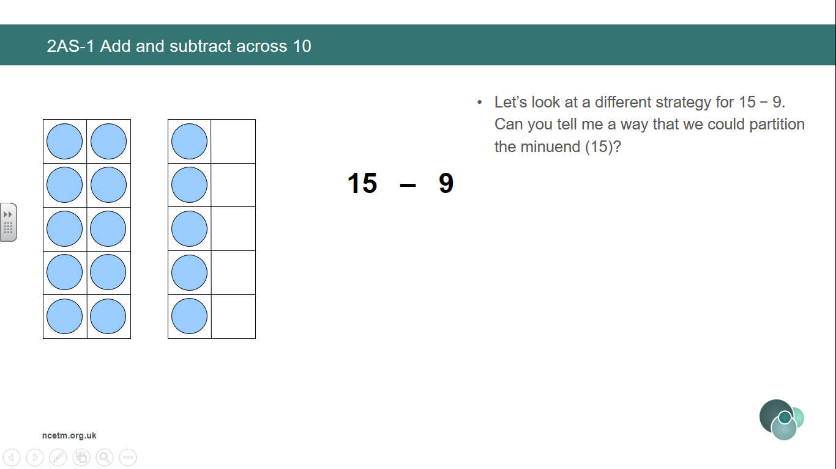

**10 – 9 = 1**

**1 + 5 = 6**

**15 – 9 = 6**

3

**Addition and Subtraction**

**Year 2**

**Solve Comparative Addition and Difference Problems**

**Vocabulary:**

Part Whole One Two Three Four Five Six Seven Eight Nine Ten Represents Compose Combine Partition Total Part-Part-Whole (Cherry) model Tens Frame Fingers Five and-a-bit Systematic Plus + Minus - Equal to = Addition Subtraction Quantity Increase Decrease First, Then, Now Expression Equation Difference Bar model

Addend + Addend = Sum Minuend – Subtrahend = Difference

Addend + Addend = Sum Minuend – Subtrahend = Difference

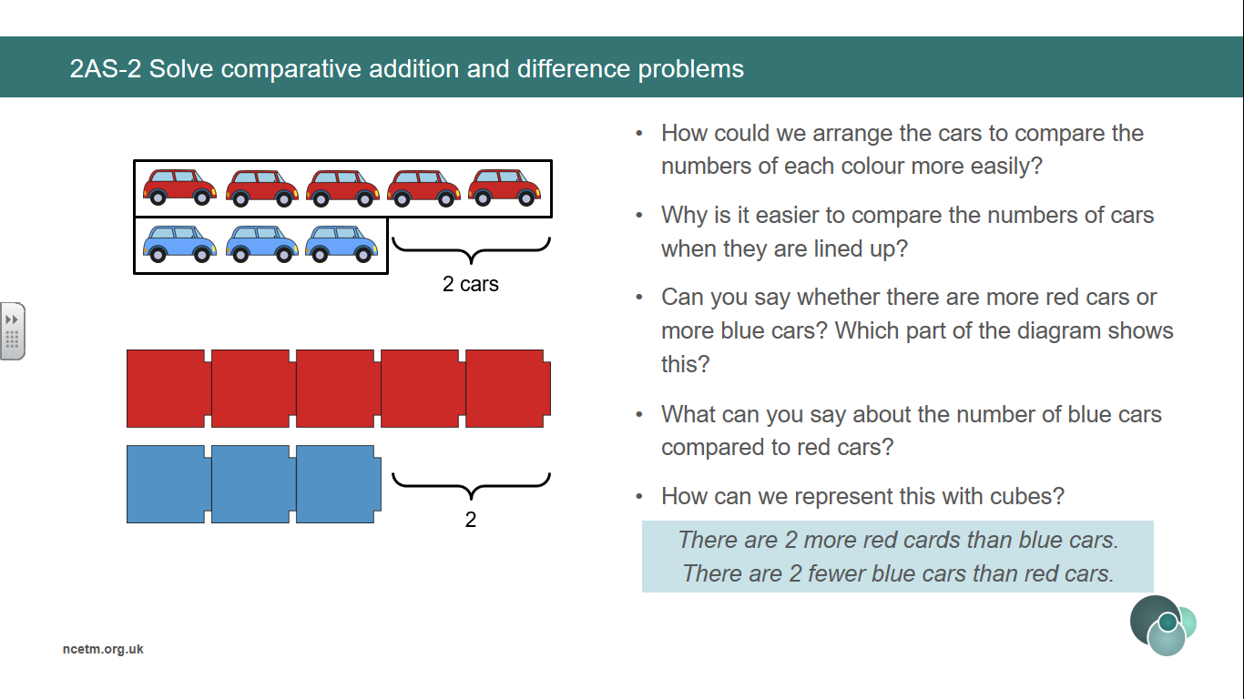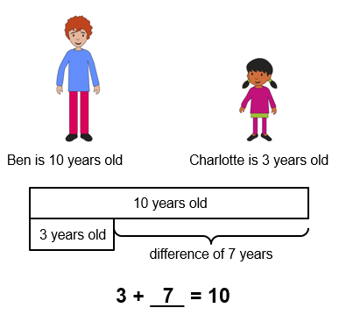

**Represent a range of comparison contexts.**

**Ben is 7 years older than Charlotte.**

**Charlotte is 7 years younger than Ben.**

**Line up sets of objects in a bar model structure to support comparison.**

**There are 2 fewer blue cars than red cars.**

**There are 2 more red cars that blue cars.**

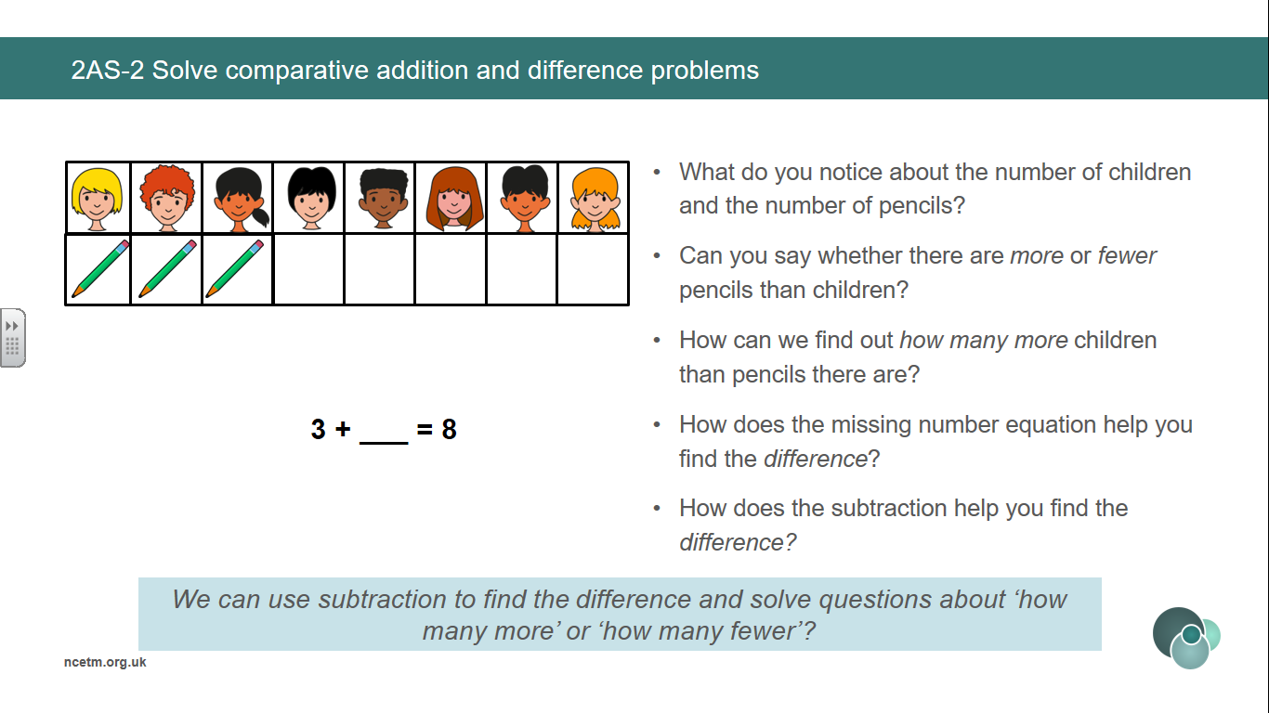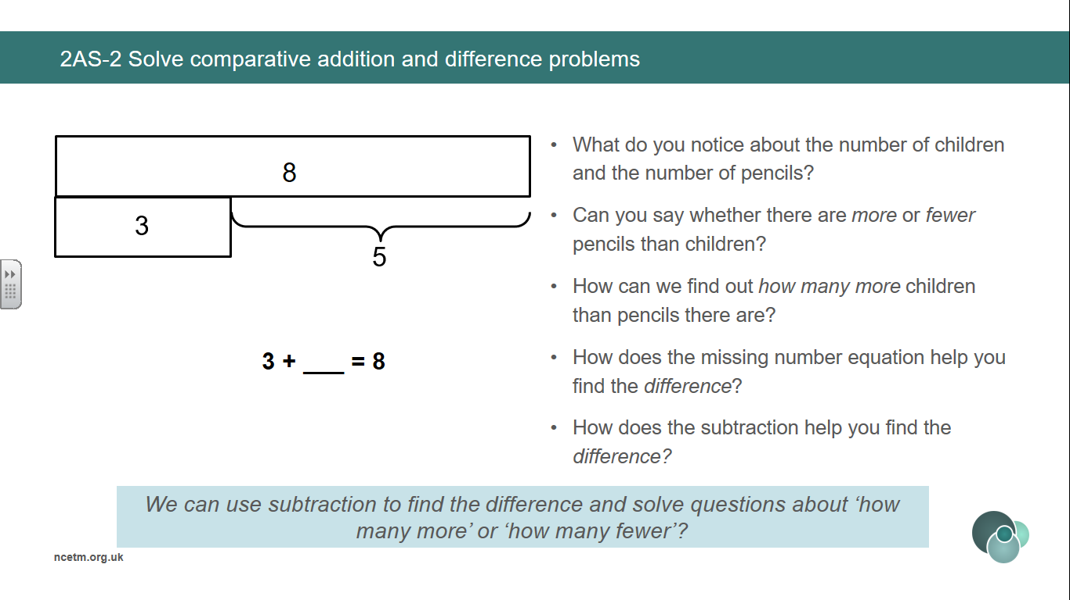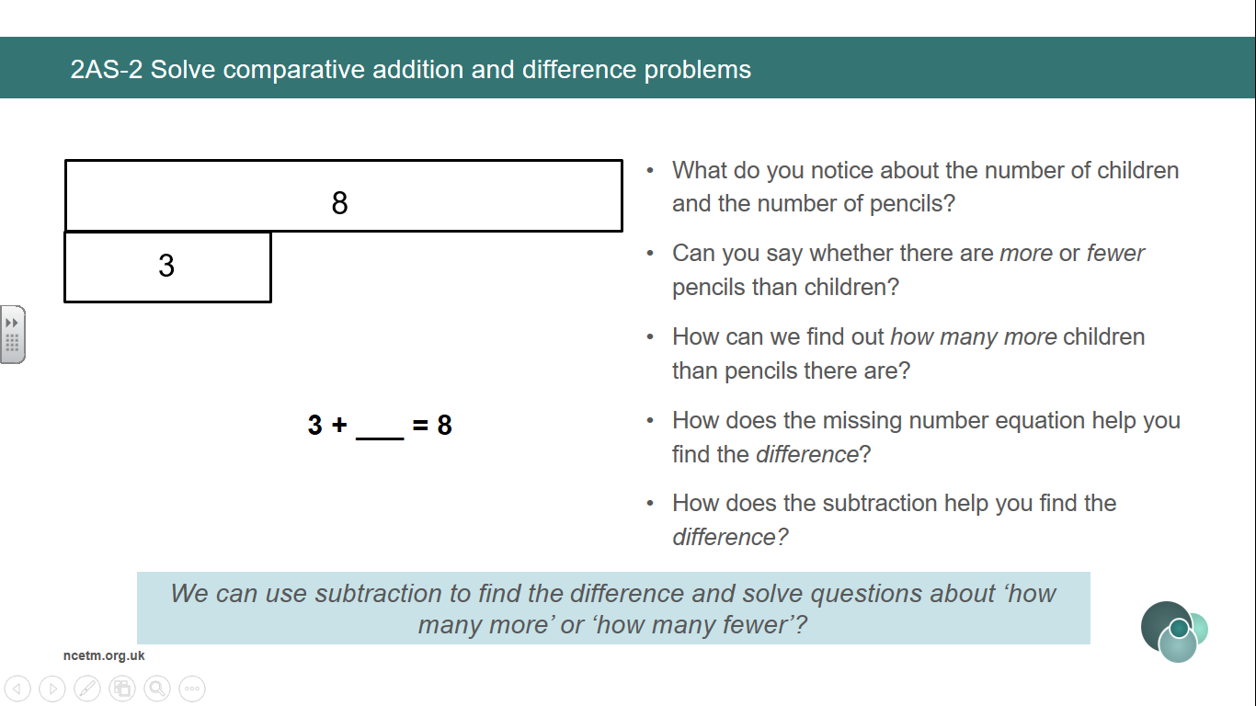

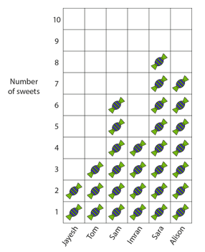

**We can use subtraction to help solve difference problems / missing addend problems about ‘how many more?’ and ‘how many fewer?’**

**3 + __ = 8**

**8 – 3 = 5**

**Create contexts for recognising the difference/comparative addition structure with all representations below.**

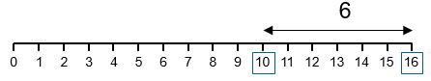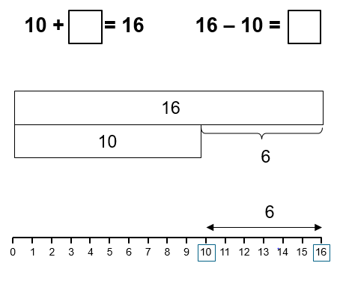



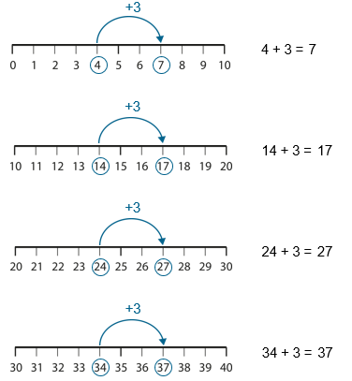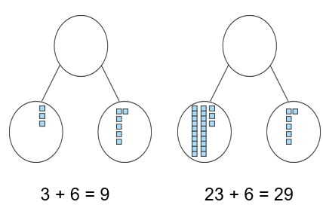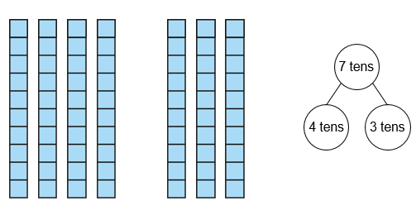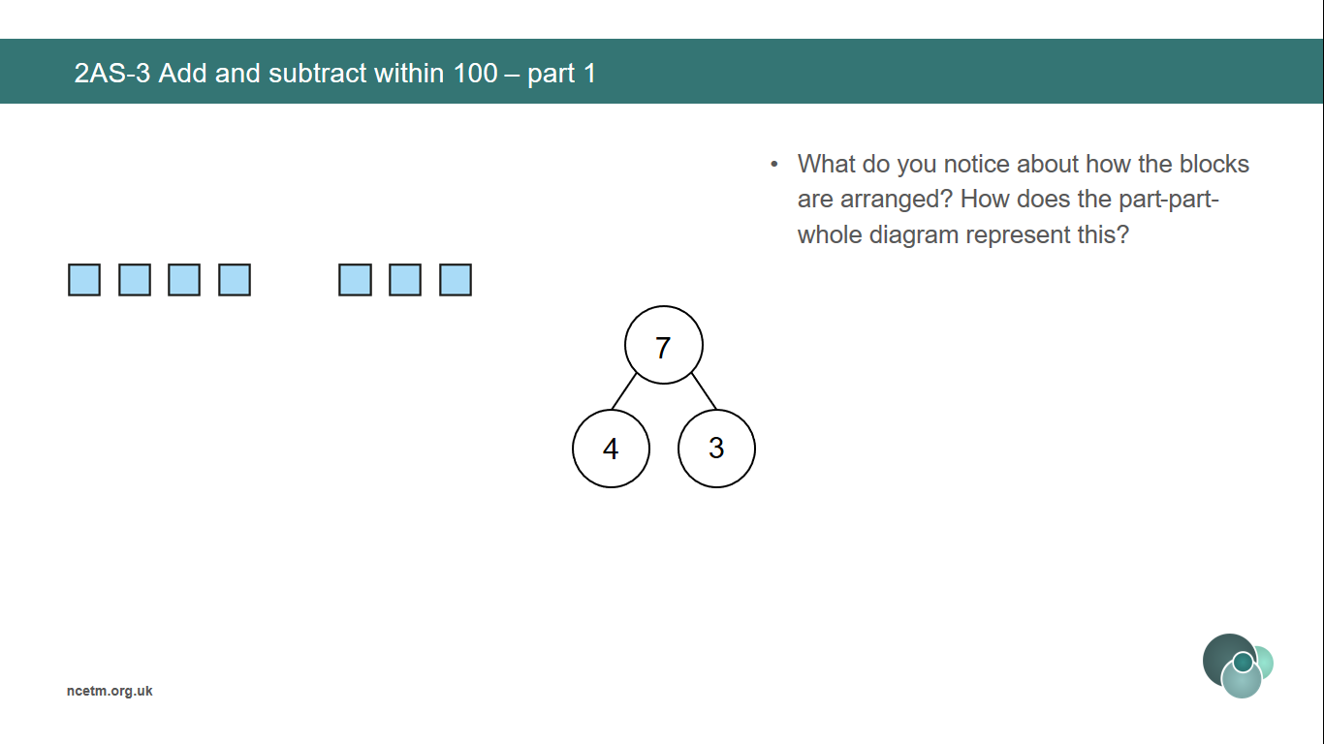

**Generalise that adding/subtracting within 10 can be applied to adding a 2 digit number with a 1 digit number – not crossing the tens boundary.**

**I know that 4 plus 3 is equal to 7.**

**So, 1 ten and 4 ones plus 3 ones is equal to 1 tens and 7 ones.**

**14 + 3 = 17.**

**70 – 40 = 30**

**Use known facts within 10 to add/subtract ones to/from a 2 digit number.**

**I know that 3 plus 6 is equal to 9.**

**So, 2 tens and 3 ones plus 6 ones is equal to 2 tens and 9 ones.**

**23 + 6 = 29.**

**70 – 40 = 30**

**Use known facts within 10 to add/subtract multiples of 10.**

**I know that 4 plus 3 is equal to 7.**

**So, 4 tens plus 3 tens is equal to 7 tens.**

**40 + 30 = 70.**

**70 – 40 = 30**

**Vocabulary:**

Part Whole Ones Tens Represents Compose Combine Partition Total Part-Part-Whole (Cherry) model Tens Frame Deines Plus + Minus - Equal to = Addition Subtraction Expression Equation Exchange Count on Count back Number line Tens Boundary

Addend + Addend = Sum Minuend – Subtrahend = Difference

Addend + Addend = Sum Minuend – Subtrahend = Difference

**Addition and Subtraction**

**Year 2**

**Add and Subtract within 100 (1).**

**Vocabulary:**

Part Whole Ones Tens Represents Compose Combine Partition Total Part-Part-Whole (Cherry) model Tens Frame Deines Plus + Minus - Equal to = Addition Subtraction Expression Equation Exchange Count on Count back Number line Tens Boundary

Addend + Addend = Sum Minuend – Subtrahend = Difference

Addend + Addend = Sum Minuend – Subtrahend = Difference

**Addition and Subtraction**

**Year 2**

**Add and Subtract within 100 (2).**

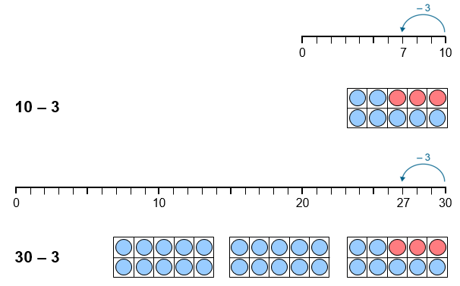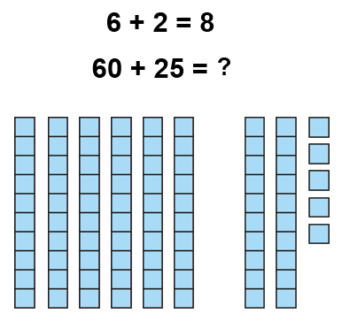

**Use knowledge of subtracting from 10 to subtract a single-digit number from a multiple of 10.**

**I know that 10 minus 3 is equal to 7.**

**So, 3 tens minus 3 ones is equal to 2 tens and 7 ones.**

**30 - 3 = 27.**

**Use known facts within 10 to add/subtract multiples of 10 to a 2 digit number.**

**I know that 6 plus 2 is equal to 8.**

**So, 6 tens plus 2 tens is equal to 8 tens. Then add the additional 5 ones.**

**60 + 25 = 85.**

**70 – 40 = 30**

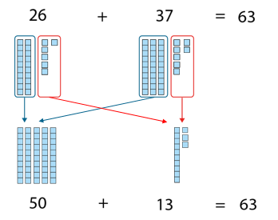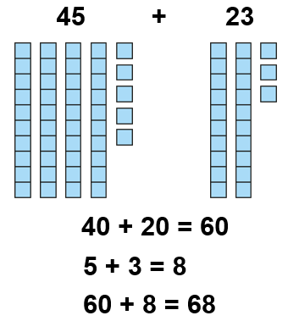

**Partition both addends to add efficiently without crossing the tens boundary.**

**Partition both addends to add efficiently when the ones require an exchange.**

**Vocabulary:**

Part Whole Ones Tens Represents Compose Combine Partition Total Part-Part-Whole (Cherry) model Tens Frame Deines Plus + Minus - Equal to = Addition Subtraction Expression Equation Exchange Count on Count back Number line Tens Boundary

Addend + Addend = Sum Minuend – Subtrahend = Difference

**Addition and Subtraction**

**Year 2**

**Add and Subtract within 100 (3).**

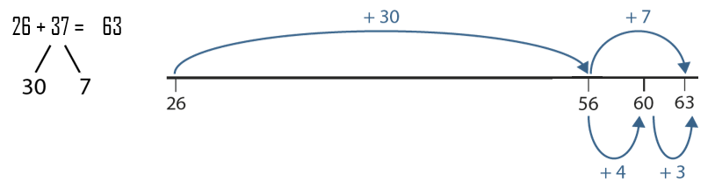

**Partition one addend and count on in ones and tens.**

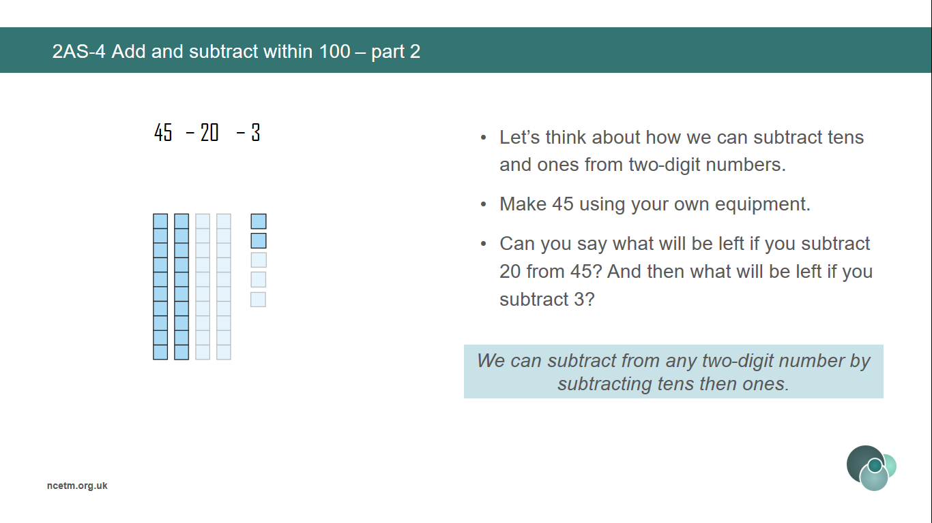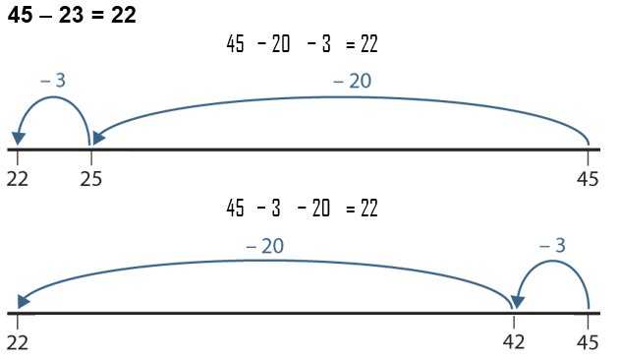

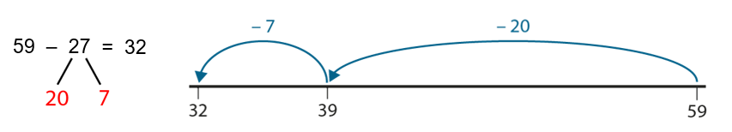

**Subtract from any two-digit number by portioning the subtrahend into tens and ones and counting back.**

**Subtract from any two-digit number by subtracting tens then ones without crossing a tens boundary.**

**Vocabulary:**

Part Whole Ones Tens Represents Compose Combine Partition Total Part-Part-Whole (Cherry) model Deines 100 square Plus + Minus - Equal to = Addition Subtraction Expression Equation Exchange Complements

Addend + Addend = Sum

**Addition and Subtraction**

**Year 3**

**Calculate complements to 100.**

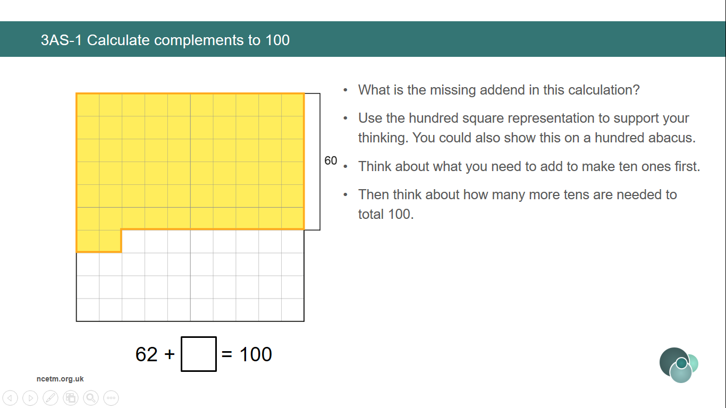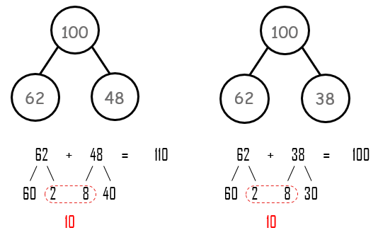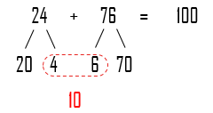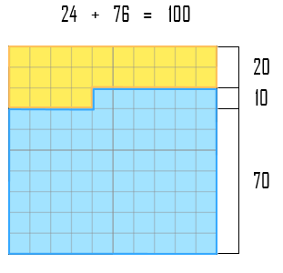

**Solve missing number problems that sum to 100.**

**Compare equations which do and do not sum to 100.**

**Use knowledge of subtracting from 10 to subtract a single-digit number from a multiple of 10.**

**First we make 10 ones. The ones digits add up to make 1 ten, so we need 9 more tens to make a total of 100.**

**Vocabulary:**

Ones Tens Represents Compose Combine Total Deines Plus + Minus - Equal to = Addition Subtraction Equation Regroup Algorithm

Addend + Addend = Sum

Minuend – Subtrahend = Difference

**Addition and Subtraction**

**Year 3**

**Columnar Addition and Subtraction**

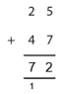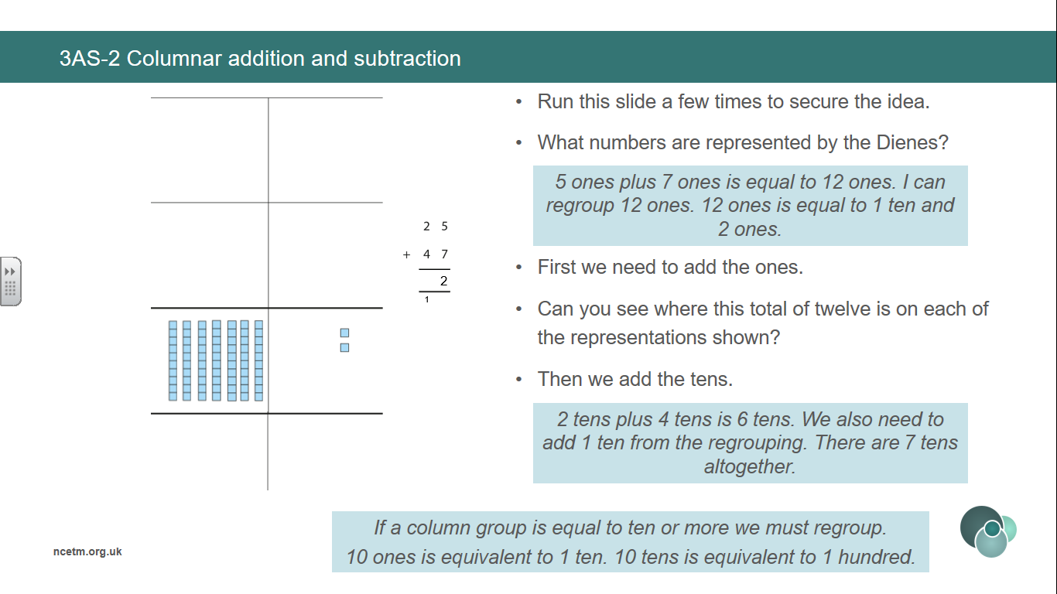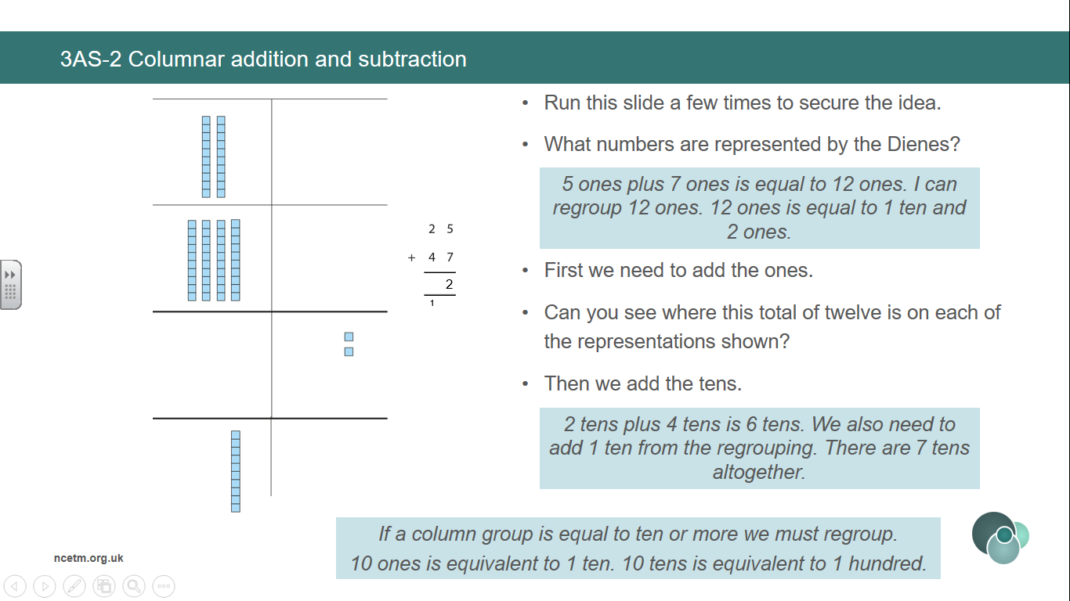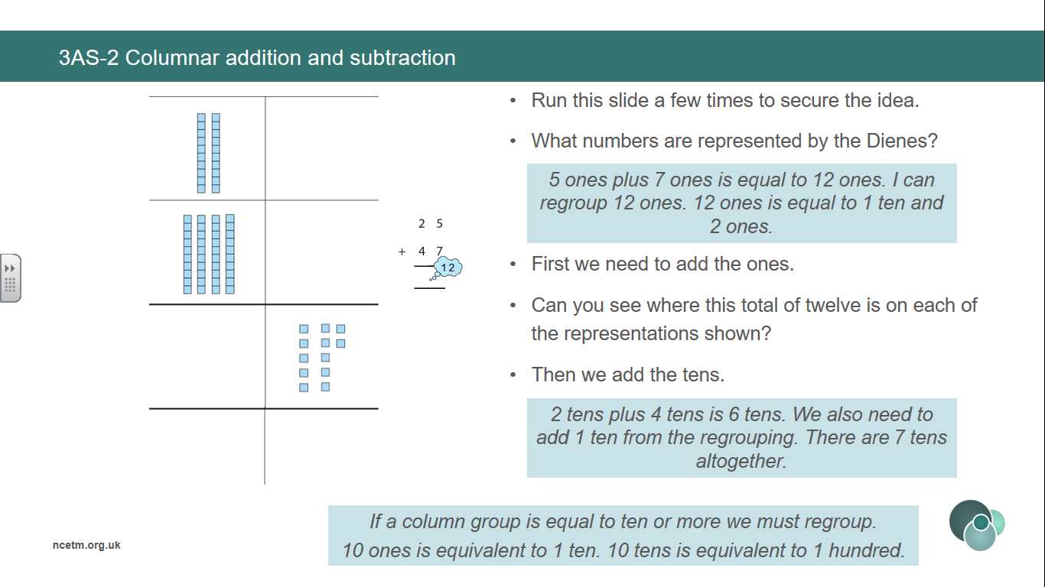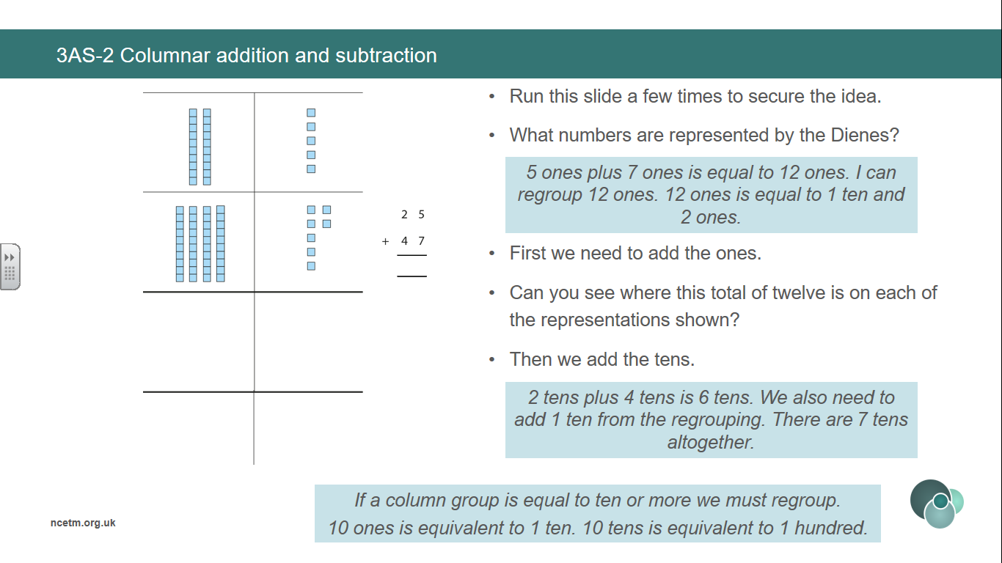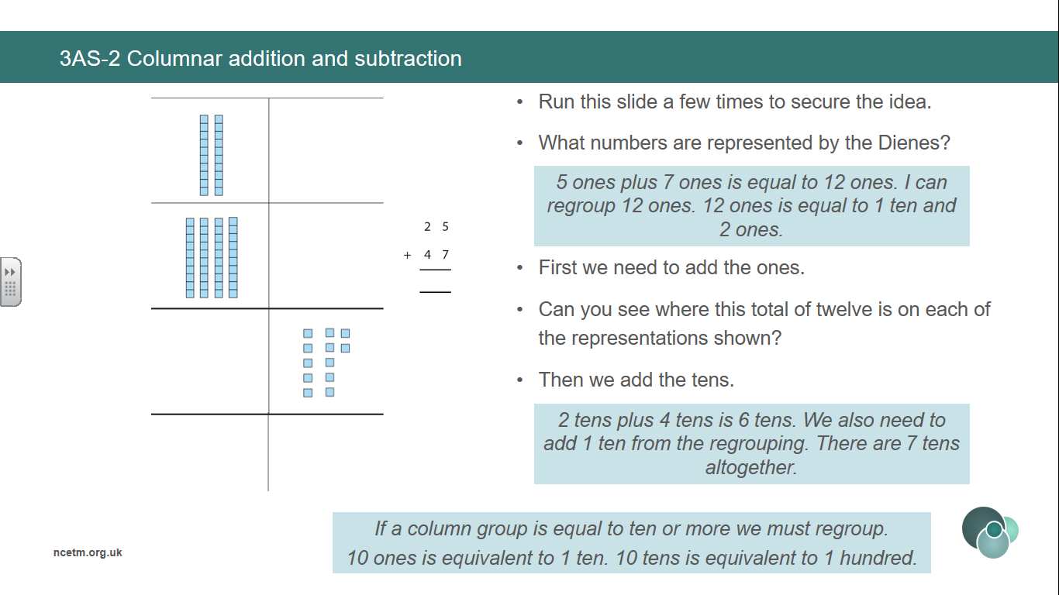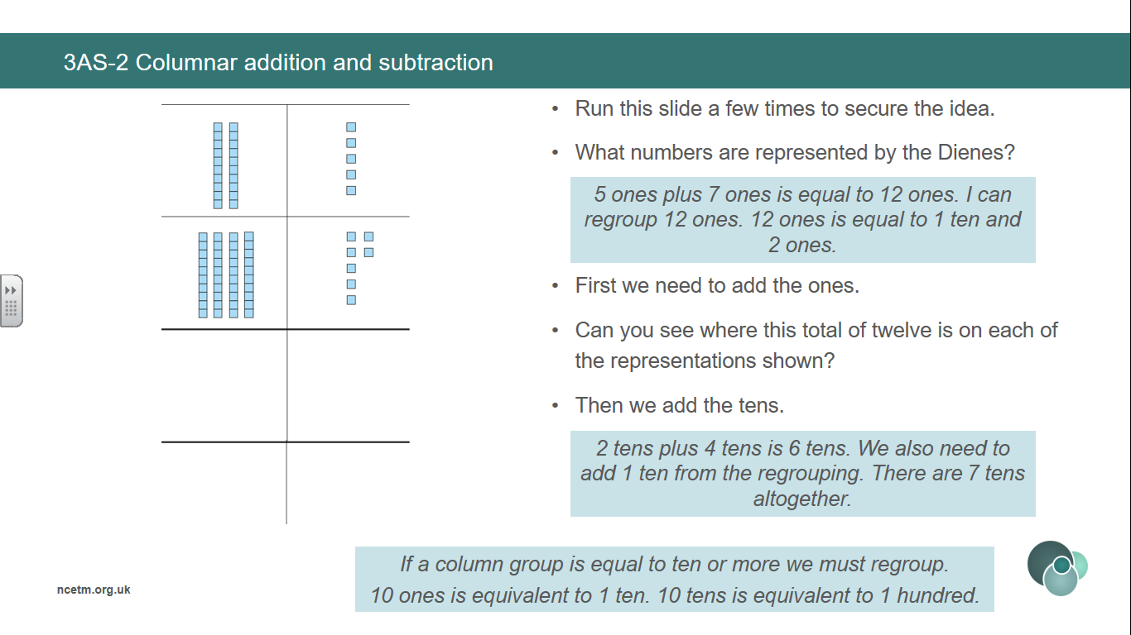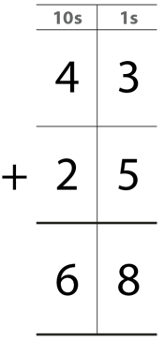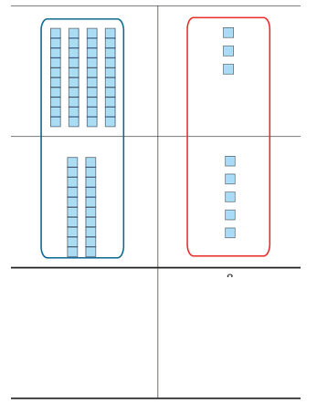

**Use deines to represent columnar addition *without exchange* pictorially before moving to abstract algorithm.**

**We add the ones. 3 ones plus 5 ones are equal to 8 ones.**

**We add the tens. 4 tens plus 2 tens is equal to 6 tens.**

**Use deines to represent columnar addition *with exchange* pictorially before moving to abstract algorithm.**

**5 ones plus 7 ones is equal to 12 ones. I can regroup 12 ones. 12 ones is equal to 1 ten and 2 ones.**

**2 tens plus 4 tens is equal to 6 tens. We also need to add 1 ten from the regrouping. There are 7 tens altogether.**

**If a column group is equal to 10 or more we must regroup. 10 ones is equal to 1 ten. 10 tens is equal to 1 hundred.**

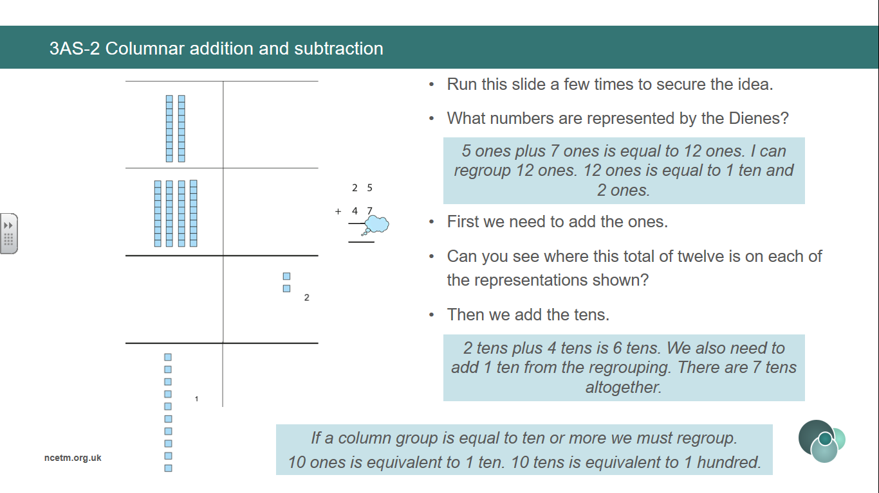

**Vocabulary:**

Ones Tens Represents Compose Combine Total Deines Plus + Minus - Equal to = Addition Subtraction Equation Expression Regroup Algorithm

Addend + Addend = Sum

Minuend – Subtrahend = Difference

**Addition and Subtraction**

**Year 3**

**Columnar Addition and Subtraction**

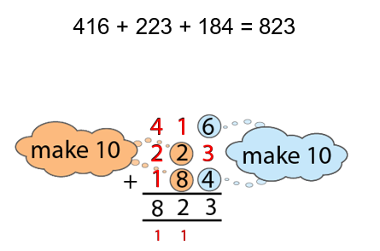

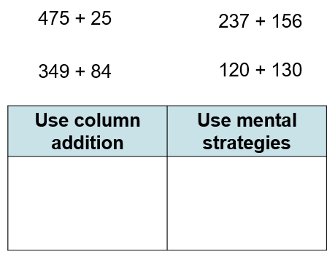

**Compare expressions which can be calculated using mental or written strategies.**

**Add 3 addends using columnar addition, using a make 10 strategy to support.**

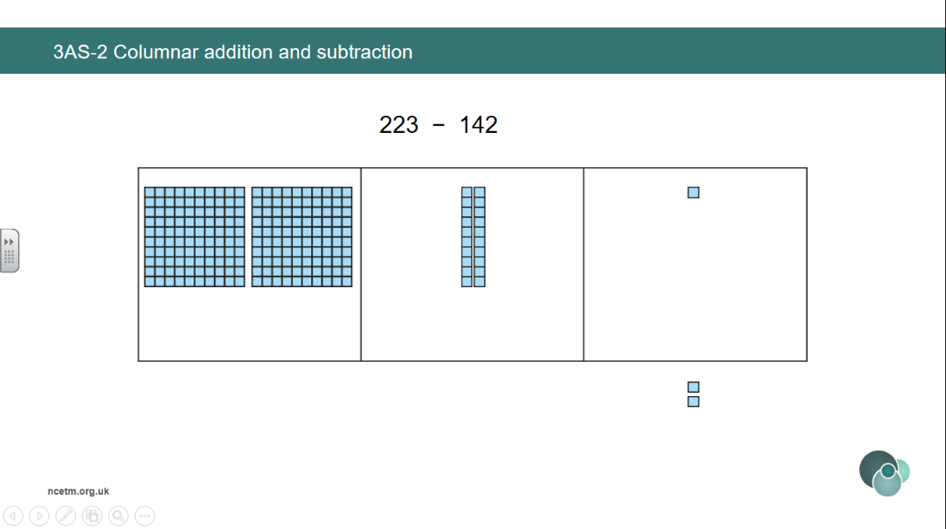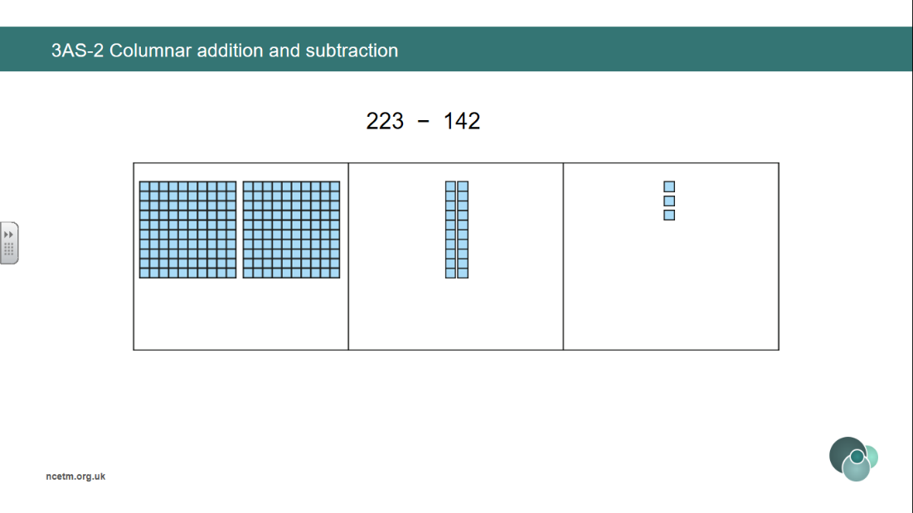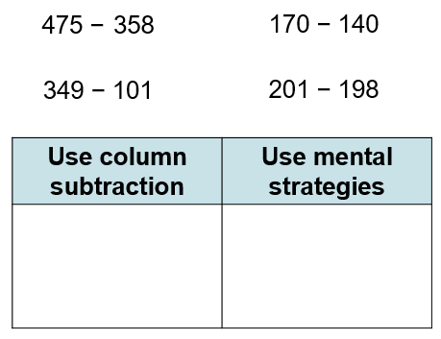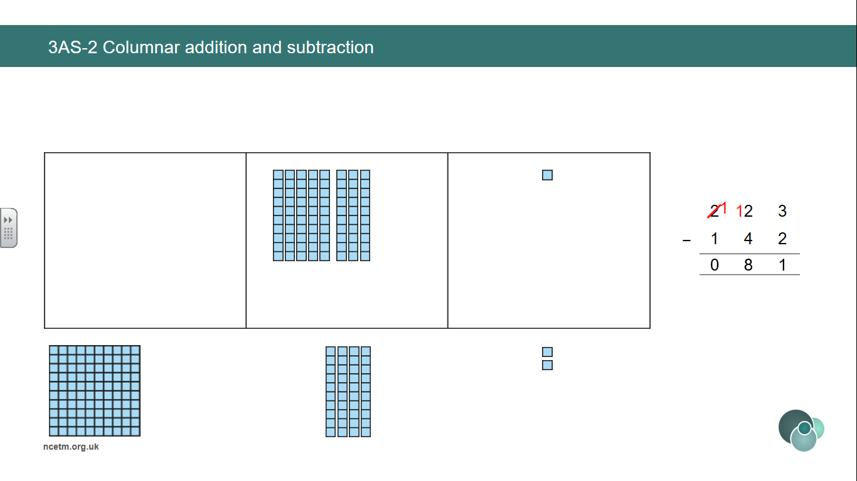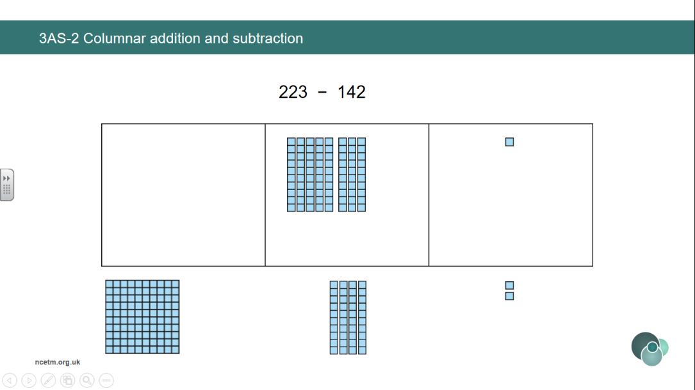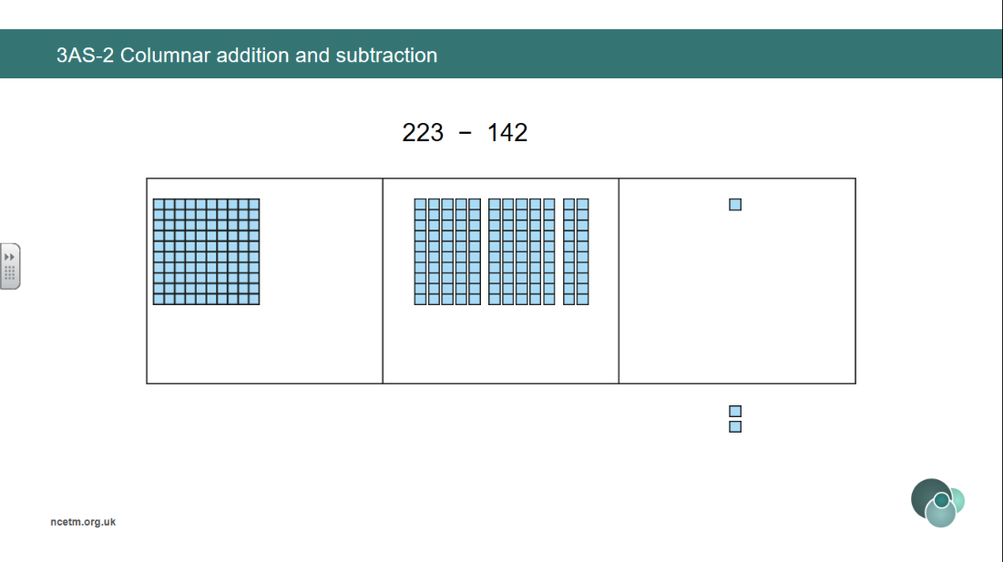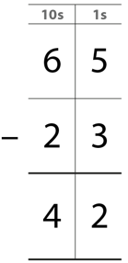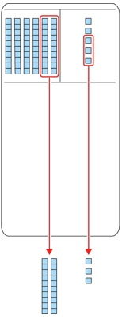

**Compare expressions which can be calculated using mental or written strategies.**

**Use deines to represent columnar subtraction *without exchange* pictorially before moving to abstract algorithm.**

**We subtract the ones. 5 ones minus 3 ones is equal to 2 ones.**

**We subtract the tens. 6 tens minus 2 tens is equal to 4 tens.**

**Vocabulary:**

Ones Tens Represents Compose Combine Total Deines Plus + Minus - Equal to = Addition Subtraction Equation Expression Regroup Algorithm

Addend + Addend = Sum

Minuend – Subtrahend = Difference

**Addition and Subtraction**

**Year 3**

**Columnar Addition and Subtraction**

**Vocabulary:**

Represents Compose Combine Total Deines Plus + Minus - Equal to = Addition Subtraction Equation Expression Bar Model Part-Part-Whole Model (Cherry) Whole Part

Addend + Addend = Sum

Minuend – Subtrahend = Difference

**Addition and Subtraction**

**Year 3**

**Manipulate the Additive Relationship**

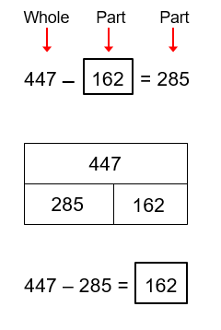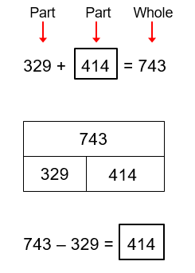

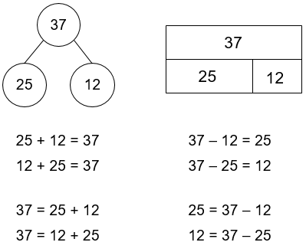

**Recognise the different equations that can be recorded based on the part-whole structure.**

**Addend + addend = sum**

**Minuend – subtrahend = difference**

**Use the part-whole structure to support finding a missing part.**

**There is a missing part. To find the missing part, we subtract the other part from the whole.**

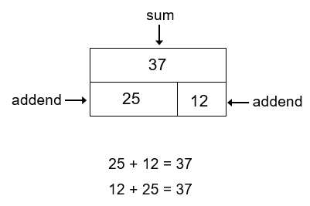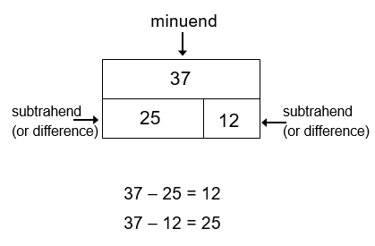

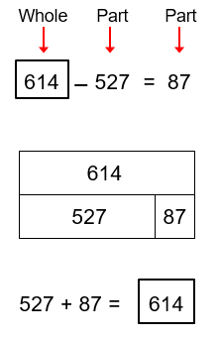

**Use the part-whole structure to support finding a missing whole.**

**There is a missing whole. To find the missing whole, we add the two parts.**

**Vocabulary:**

Additive Multiplicative Relationship Represents Compose Combine Total More than Less than Plus + Minus - Equal to = Addition Subtraction Divide ÷ Multiply x One-_____ of Equation Expression Bar Model Whole Part Difference Multiplier Unknown Sequence

Addend + Addend = Sum

Minuend – Subtrahend = Difference

**Addition and Subtraction**

**Year 6**

**Quantify additive and multiplicative relationships**

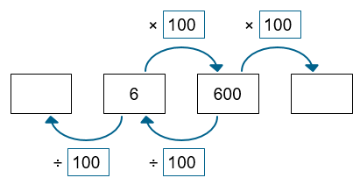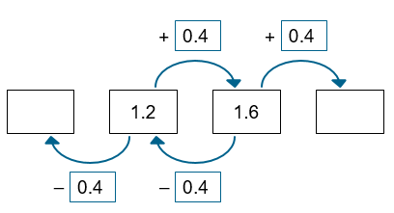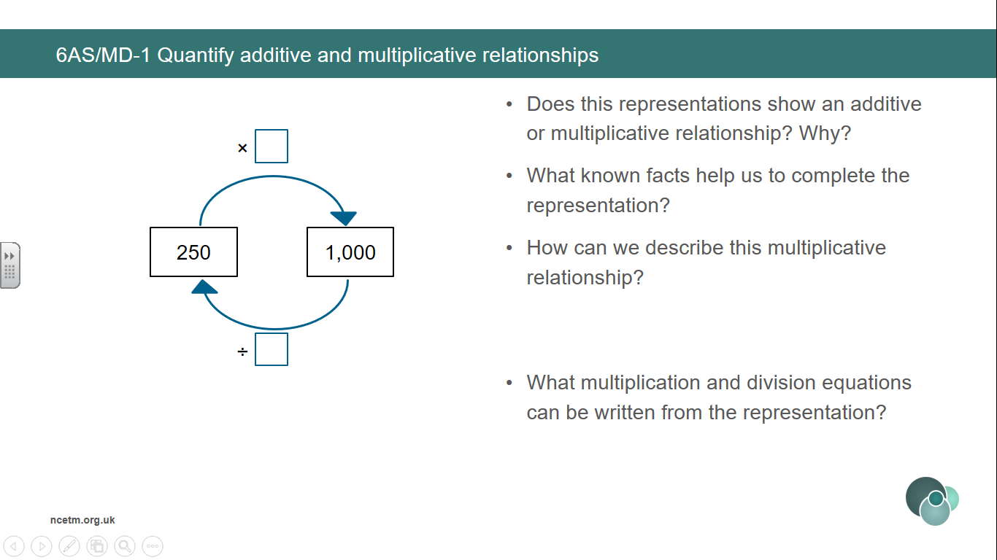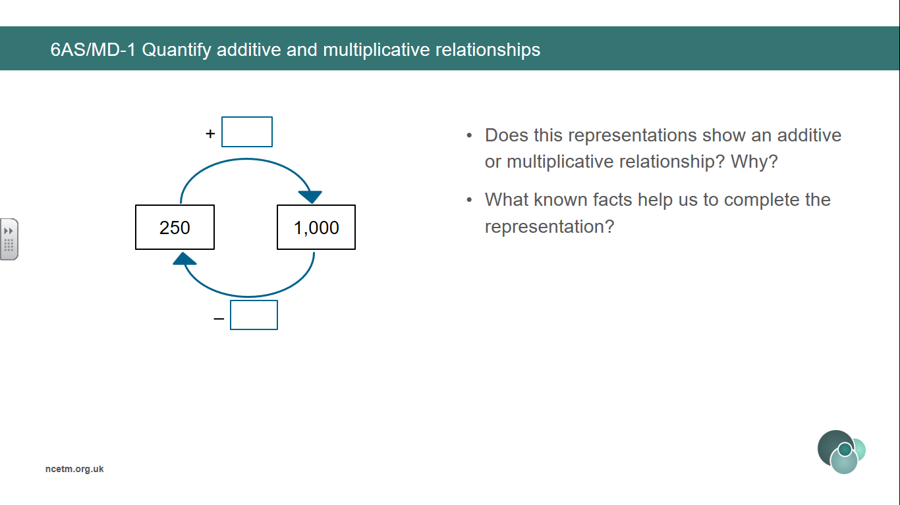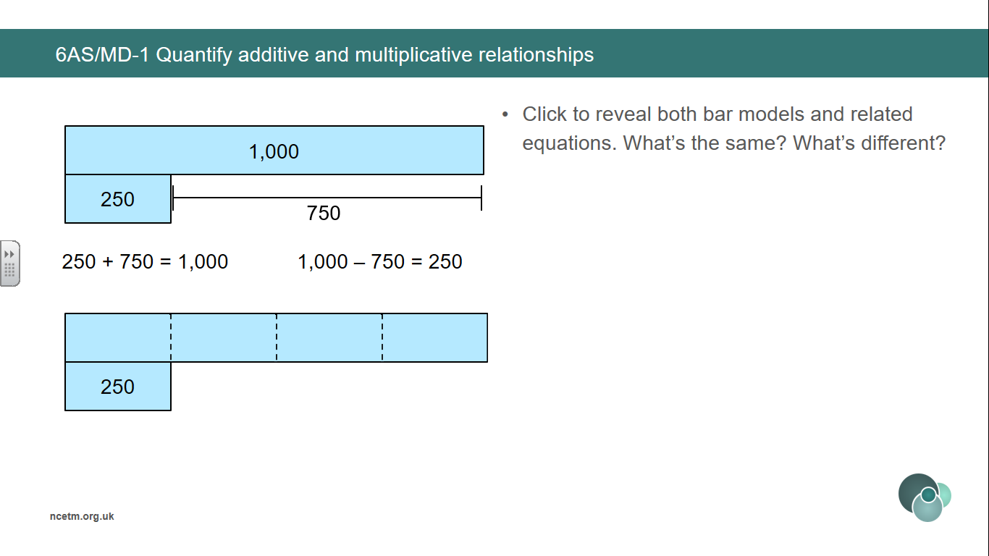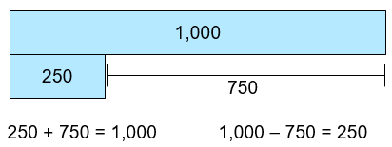

**Finding the difference can help calculate the unknown terms in a sequence.**

**Finding the known multiplier can help calculate the unknown terms in a sequence.**

**1000 is ___ times the size of 250.**

**250 is one-_____ of 1000.**

**To find one-quarter of a number, we divide by 4.**

**1000 is ___ more than 250.**

**250 is ____ less than 1000.**

**The relationship between two numbers can be expressed both additively and multiplicatively.**

**Vocabulary:**

Additive Multiplicative Relationship Represents Compose Combine Total More than Less than Plus + Minus - Equal to = Addition Subtraction Divide ÷ Multiply x One-_____ of Equation Expression Bar Model Whole Part Difference Multiplier Unknown Sequence

Addend + Addend = Sum

Minuend – Subtrahend = Difference

**Addition and Subtraction**

**Year 6**

**Quantify additive and multiplicative relationships**

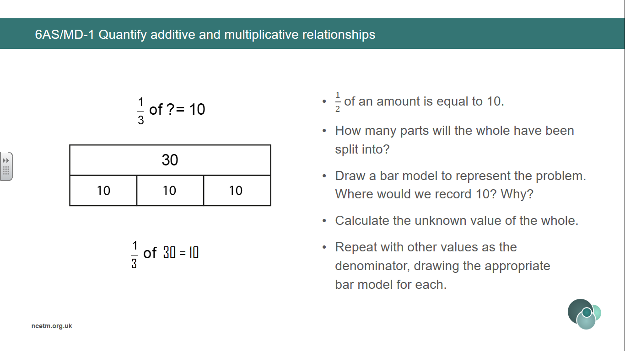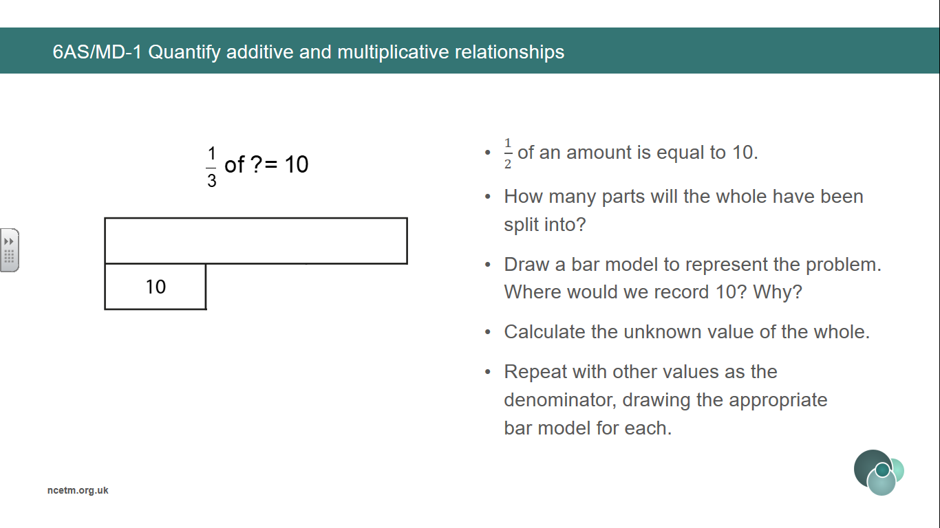

**Calculate the unknown whole by recognising how many parts the whole has been divided into.**

**Vocabulary:**

Additive Multiplicative Relationship Represents Equation Unknown Re-arrange Inverse Place Value Properties Commutative Associative Distributive Compensation

Addend + Addend = Sum Factor x Factor = Product (Multiplicand x Multiplier = Product)

Minuend – Subtrahend = Difference Dividend ÷ Divisor = Quotient

**Addition and Subtraction**

**Year 6**

**Derive Related Calculations**

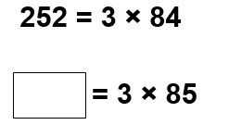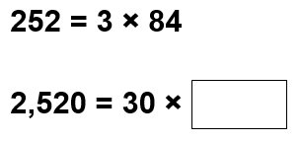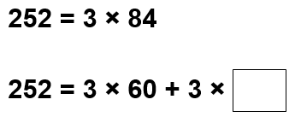

**Manipulate an equation to solve another. Pupils could:**

* **rearrange the terms;**
* **rewrite using inverse operations;**
* **apply place value;**
* **use the properties of division that correspond to the commutative, associative or distributive property of multiplication;**
* **use the compensation property.**

**Additive examples**

**Multiplicative examples**

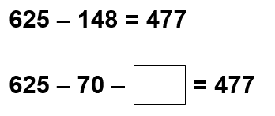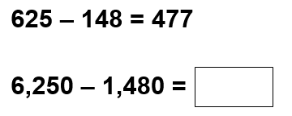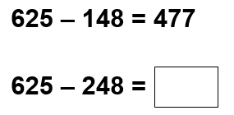

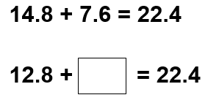

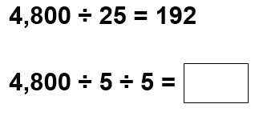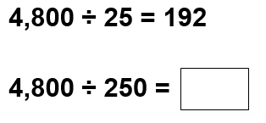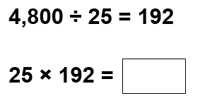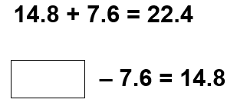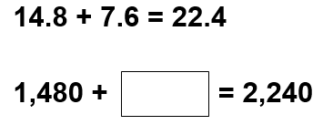

**Vocabulary:**

Additive Multiplicative Relationship Represents Equation Unknown Scale-factor Ratio Ratio Table ___ times the size one-___ the size of Vertical Horizontal

Factor x Factor = Product (Multiplicand x Multiplier = Product)

Dividend ÷ Divisor = Quotient

**Addition and Subtraction**

**Year 6**

**Solve Problems involving Ratio Relationship**

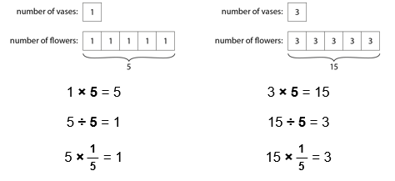

**Ratio table to compare sets of information.**

**For every ___, there are ___.**

**For every 1 litre of petrol, you can drive 7 miles.**

**For every 7 miles you will drive, you need 1 litre of petrol.**

**Extend sequences using knowledge of patterns based on ratio table.**

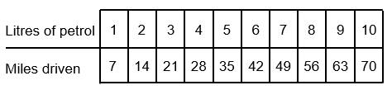

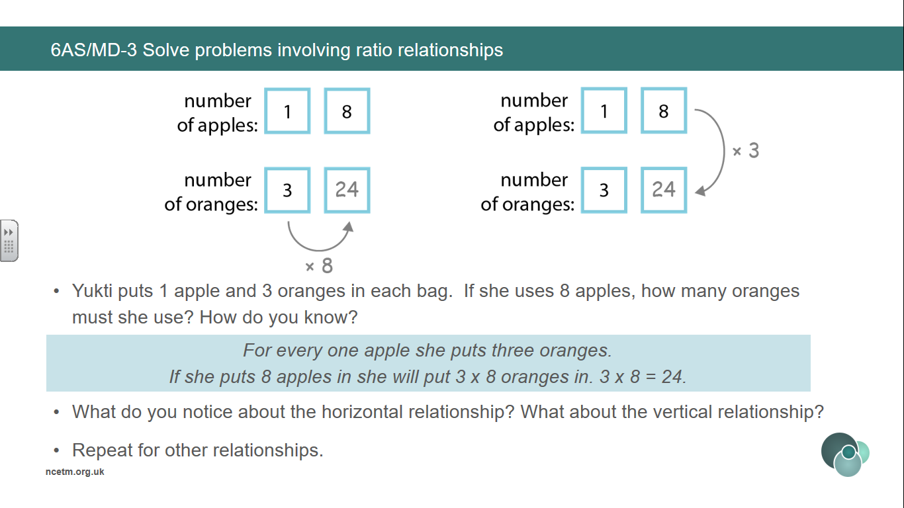

**Explore vertical and horizontal relationship between numbers.**

**For every ___, there are ___.**

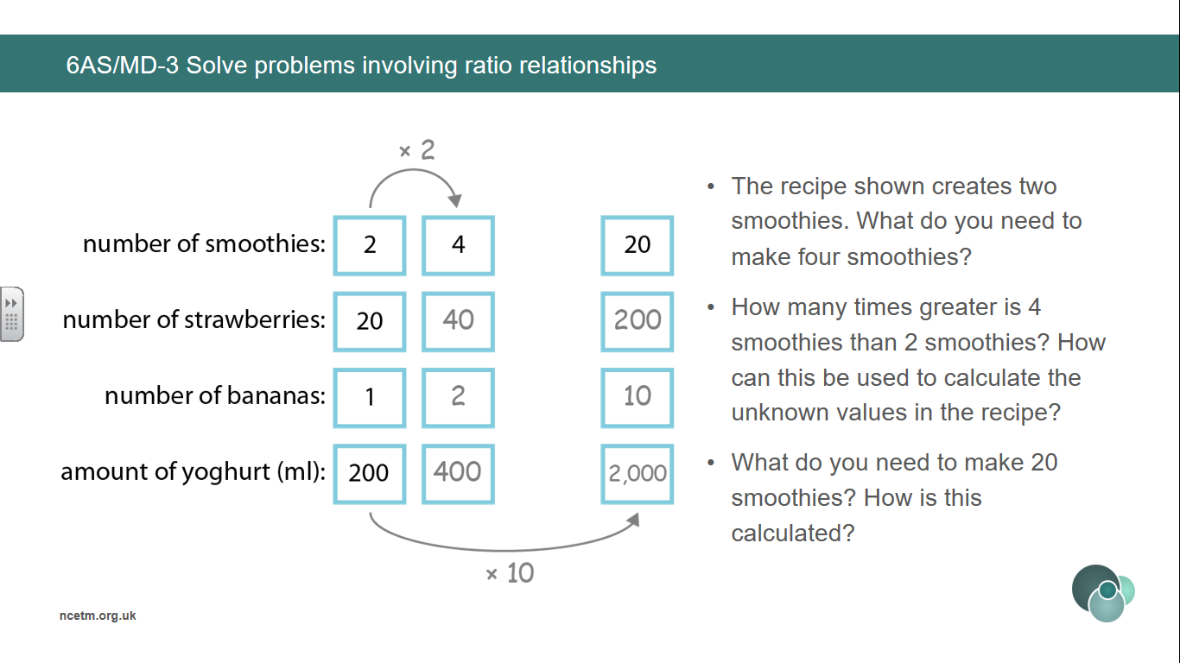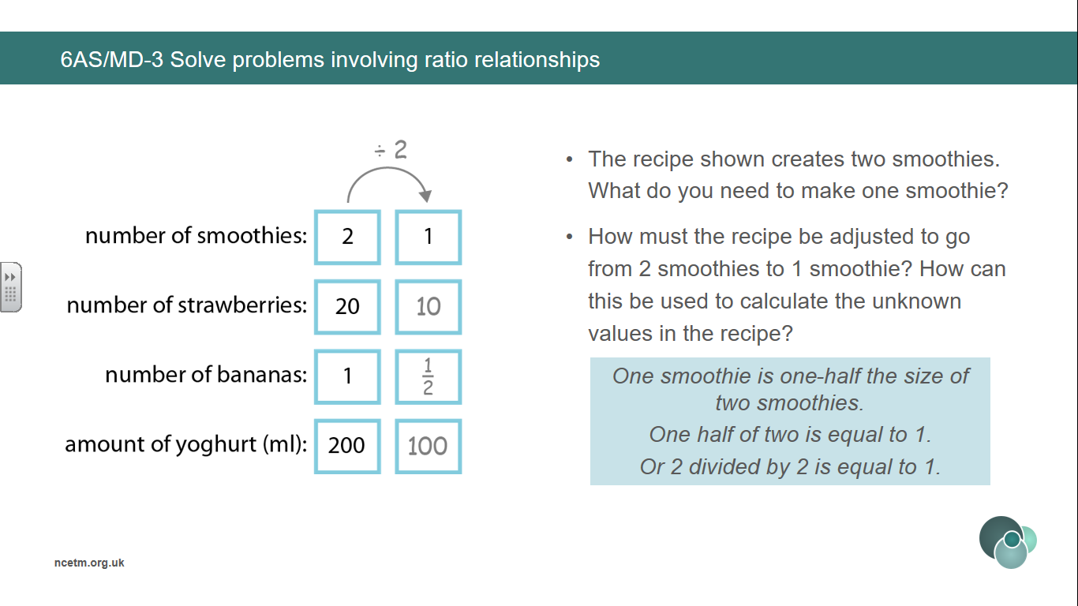

**Identify the scale-factor in order to find unknown values.**

**___ is ___ times the size of ___.**

**Therefore I must multiply/divide by ___.**

**___ is one-__ the size of ___.**

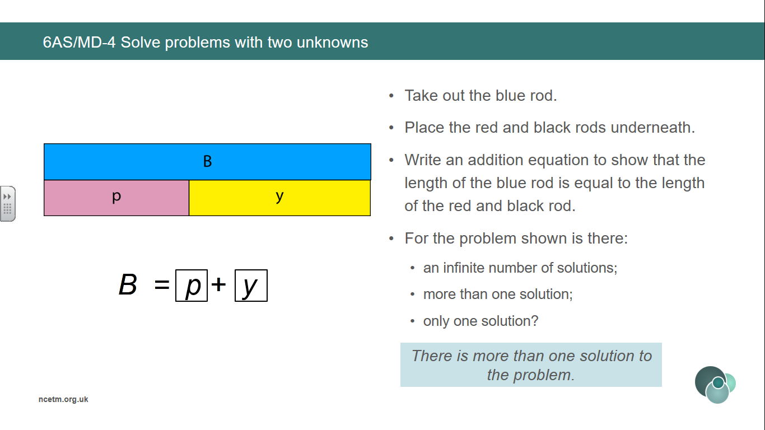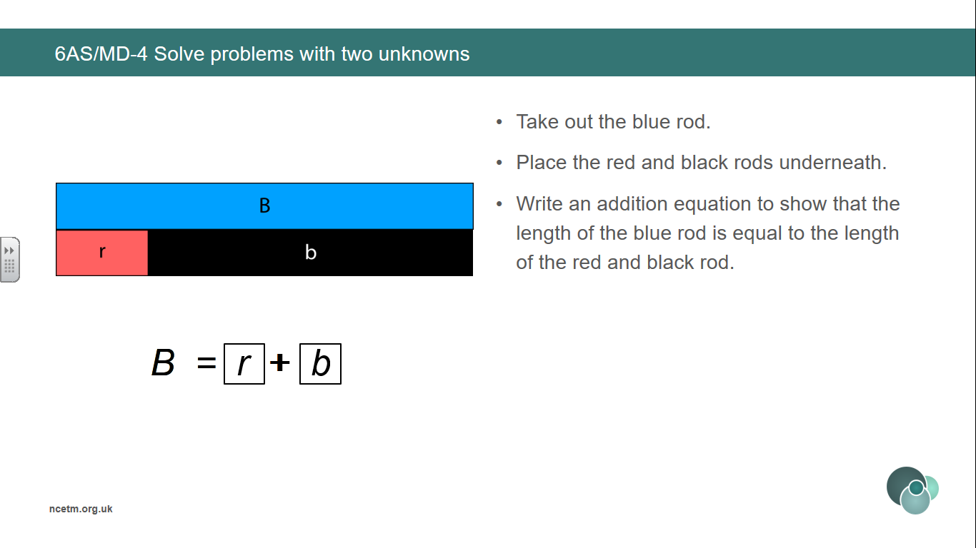

**Addition and Subtraction**

**Year 6**

**Solve Problems with Two Unknowns**

**Vocabulary:**

Additive Multiplicative Relationship Represents Equation Two Unknowns Scale-factor Ratio ___ times the size one-___ the size of Total Bar Model Structure

**Solve multiplicative problems with two unknowns when the total is known.**

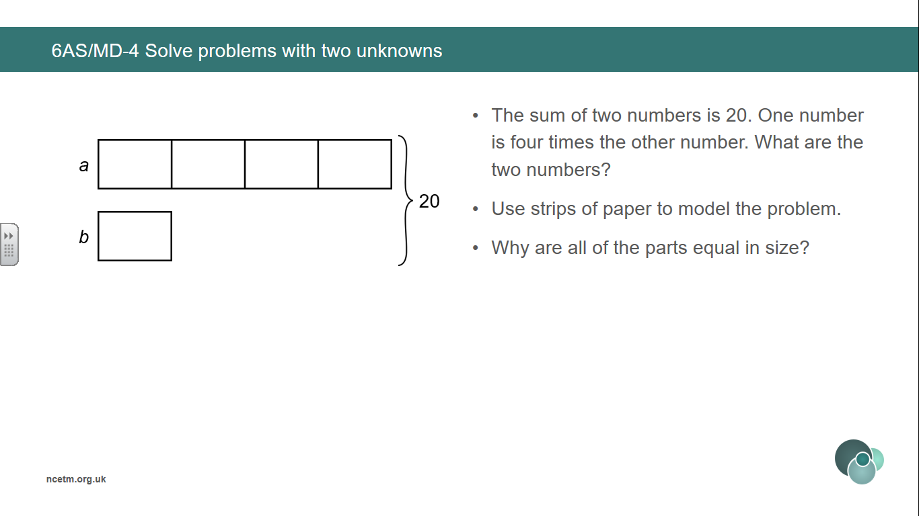

**Use Cuisenaire to find 2 bars of total length that are equal to another.**

**There is more than one solution to the problem.**

**There can be infinite solutions to a problem.**

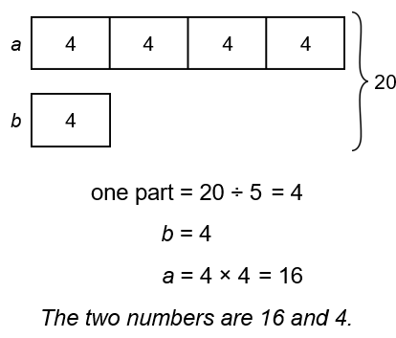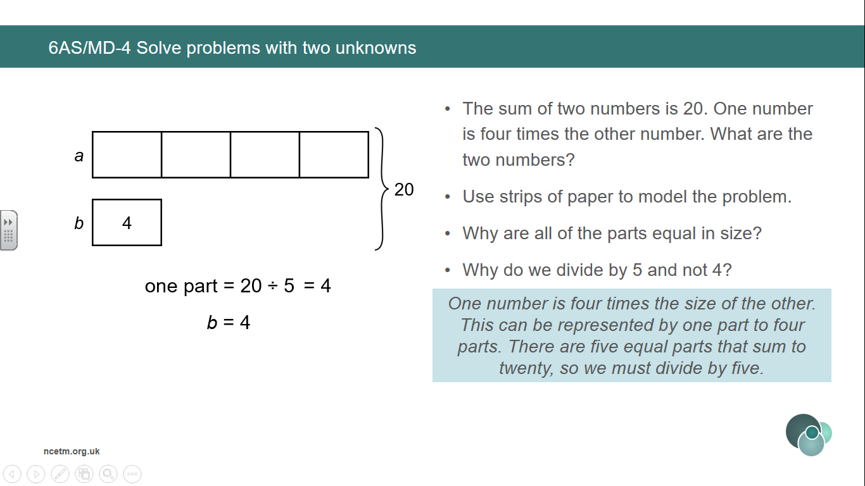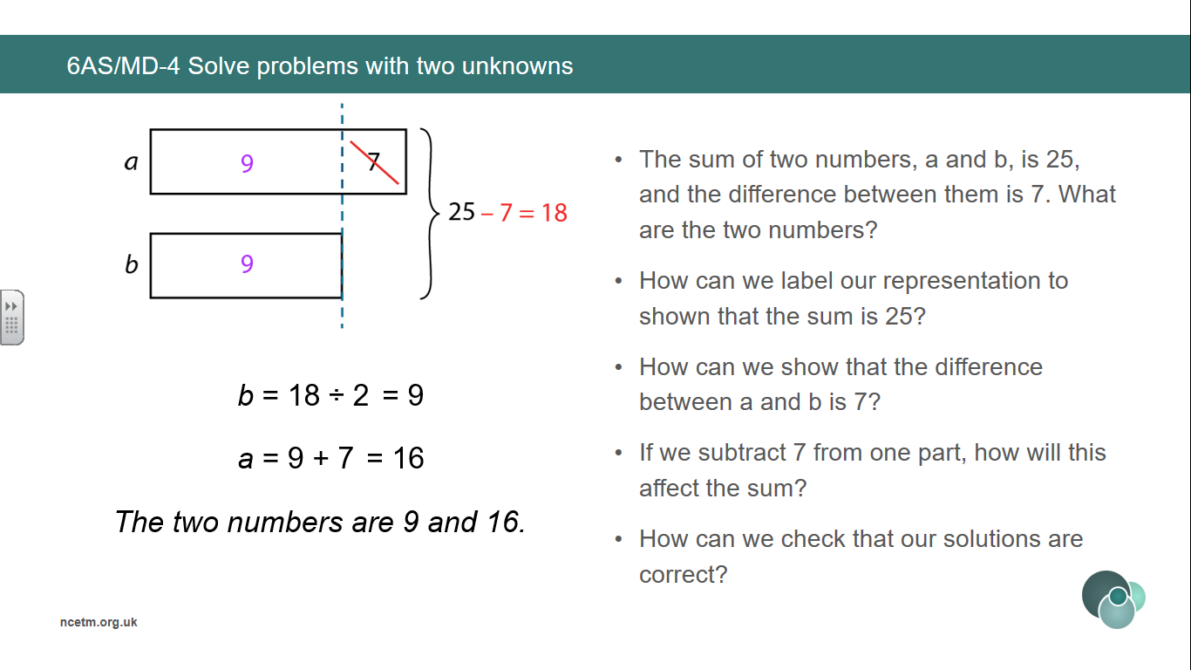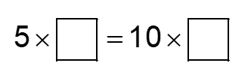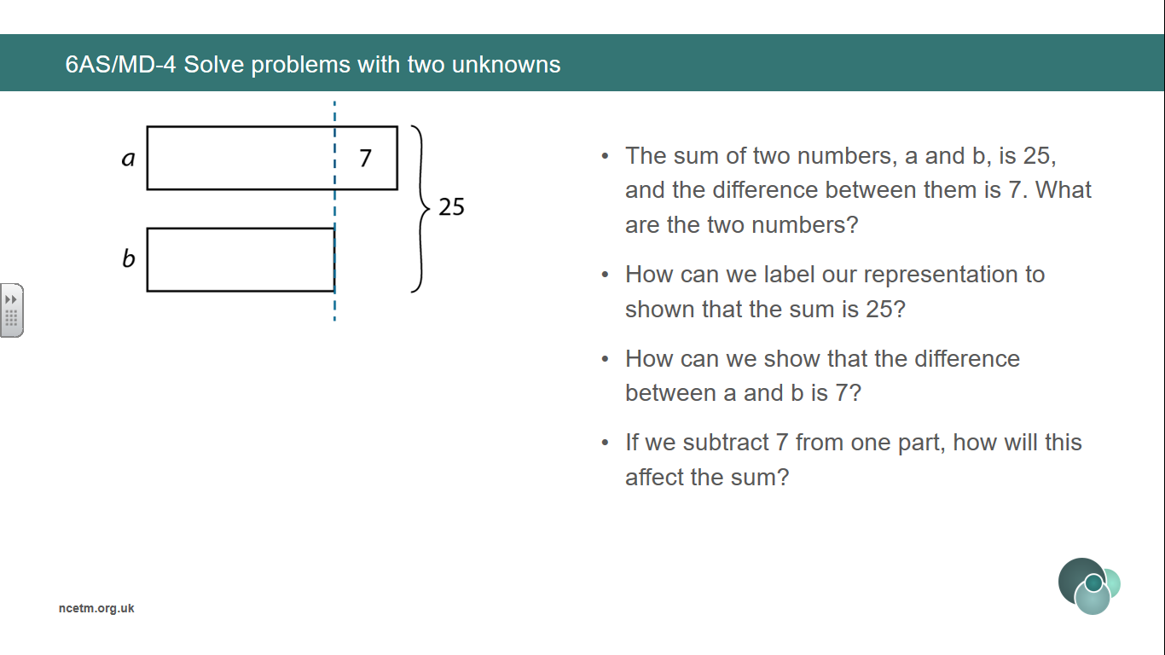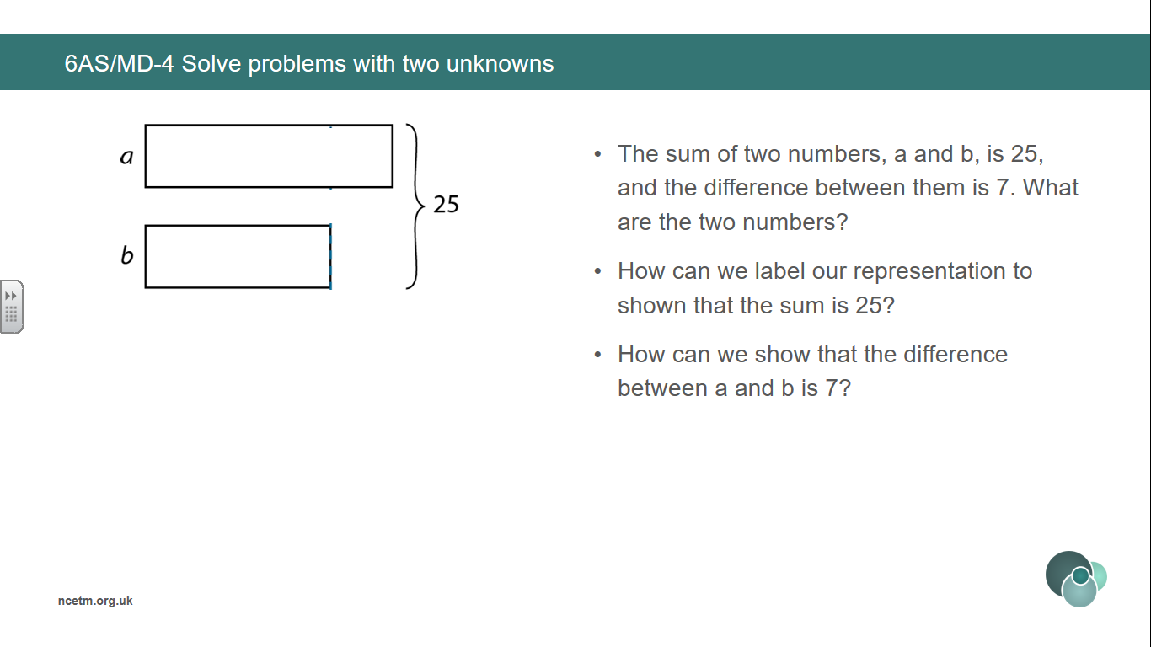v

**Solve additive problems with two unknowns when the total is known.**